

**WELSPUN VIDYA MANDIR**

A project report submitted

in Partial Fulfillment of the Requirements

**AISSCE** – All India Senior School Certificate

Examination

2023-24

In

**Informatics Practices** (065)

**Submitted By : Submitted to:**

Ma’am Nita Dubey

Roshan Panse - XII SCI - ROLL NO. -

Vansh Chavda - XII SCI - ROLL NO. -

Ritunjay Kushwaha-XII COM – ROLL NO.-

**CERTIFICATE**

This is to certify that **Roshan Panse ,Vansh Chavda , Ritunjay Kushwaha** of class XII , has completed the project on topic “**Stock Market Analysis “** in partial fulfillment of the requirement for the AISSCE Practical Examination of the Subject **Informatics Practices(065)** .

The project work reported here is as per the guidelines of **CBSE for Practical Examination** and is done under the supervision of **Mrs. Nita Dubey** during the academic year 2023-24.

Subject Teacher’s Sign Principal’s Sign

(Mrs. Nita Dubey) (Mrs. Kavita Tandon)

Examiner Sign School Seal

**CONTENT**

1. Introduction to project
2. System Requirements of the Project
3. Flow of Program Control
4. SQL Tables
5. Python Coding
6. Output of the Project

1. References / Bibliography

**INTRODUCTION**

It is an educational platform designed to provide users with a practical understanding of stock market. It is a learning tool suitable for newbies, this innovative simulation allows us to experience a risk-free exploration of stock trading without any risk to actual financial stakes.

It is a comprehensive tool that enables users to engage in simulated market scenarios. It is also a great tool for learning how to read the graphs and make analysis. The user interface, characterized by its user-friendly design and visual appeal makes it easy for the user to analyse the graph and review on the loss or profit of the organisation.

**SYSTEM REQUIREMENTS**

Operating System: Windows 7 or 10

Mac OS X 10.11 or higher, 64-bit

Linux: RHEL 6/7, 64-bit

CPU Architecture: Dual-core Intel i3 5200u or higher

Dual-core AMD Ryzen 3 3100

Higher

RAM: 4GB RAM or more

Free Disk Space: Minimum 1 GB free disk space

**DATA FLOW**

**SQL DATABASE**

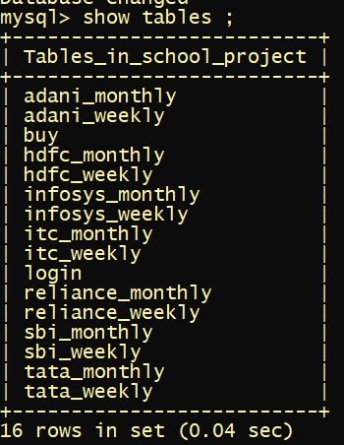

* **TABLE LOGIN**

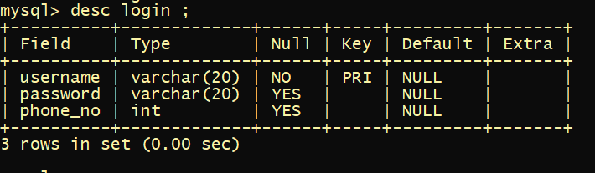

* **TABLE RELIANCE_MONTHLY**

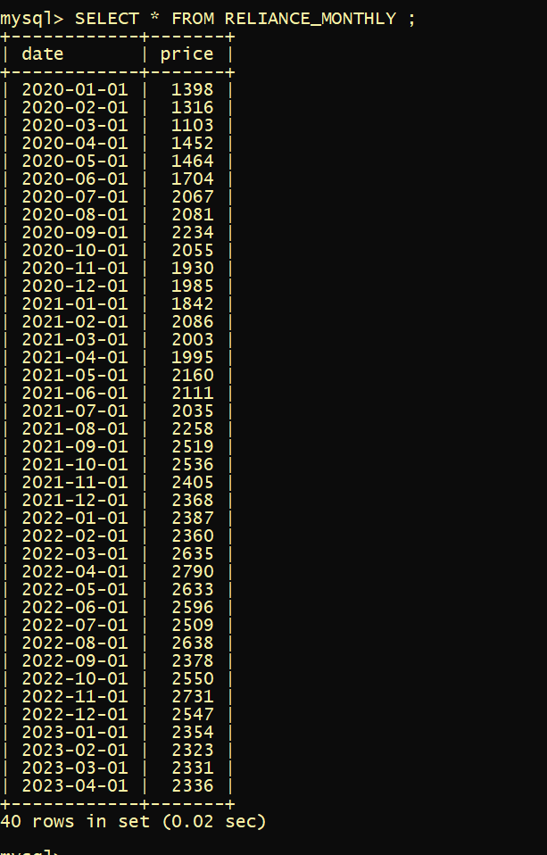

* **TABLE RELIANCE_WEEKLY**

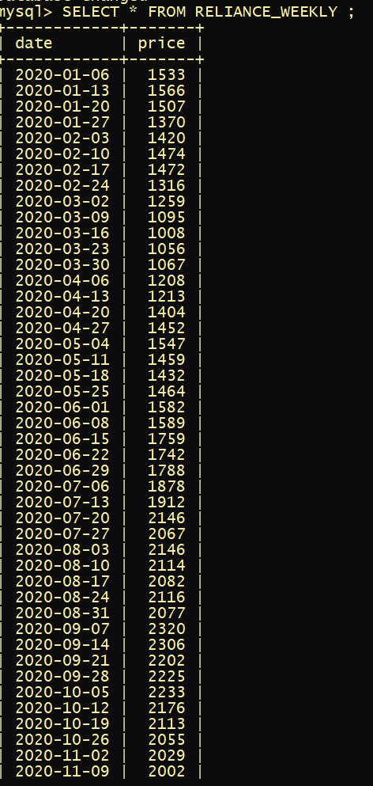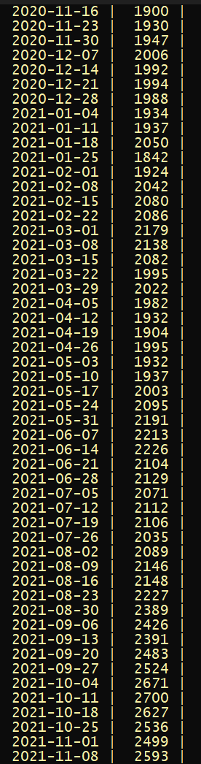

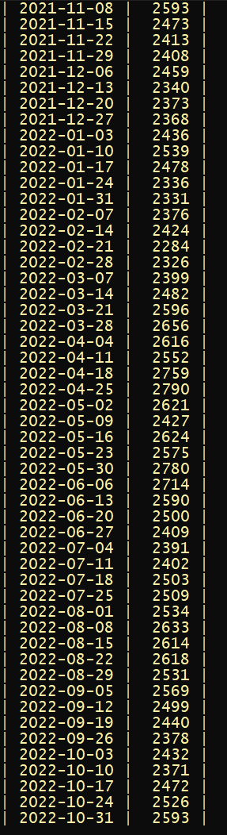 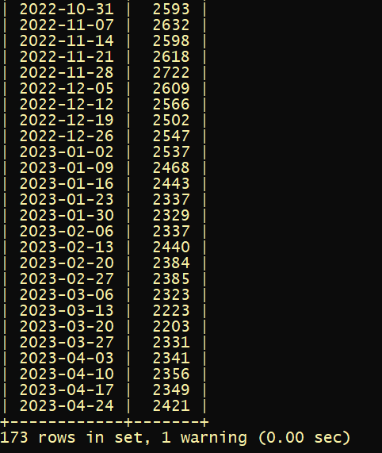

* **TABLE ADANI_MONTHLY**

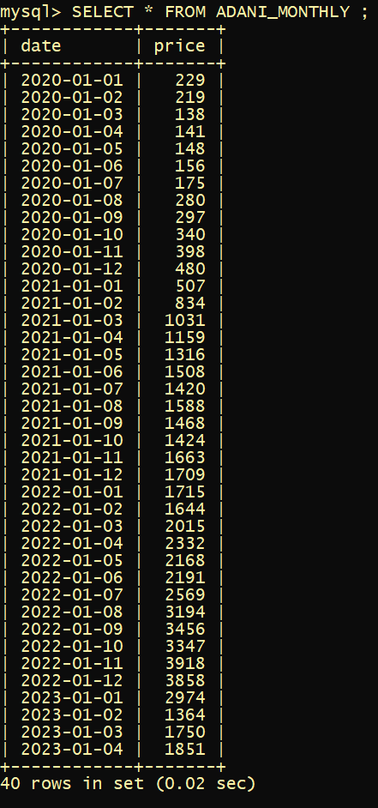

* **TABLE ADANI_WEEKLY**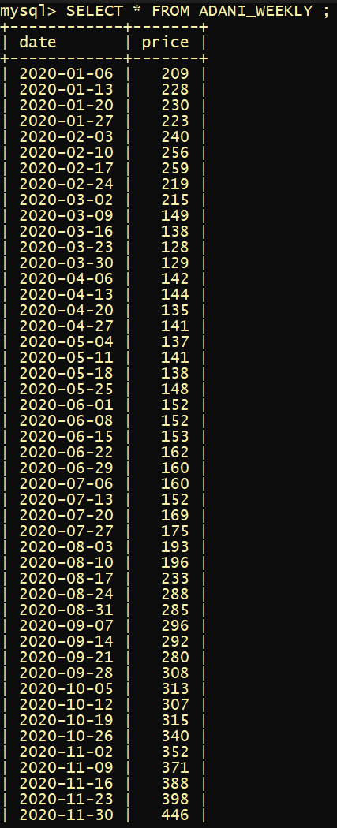 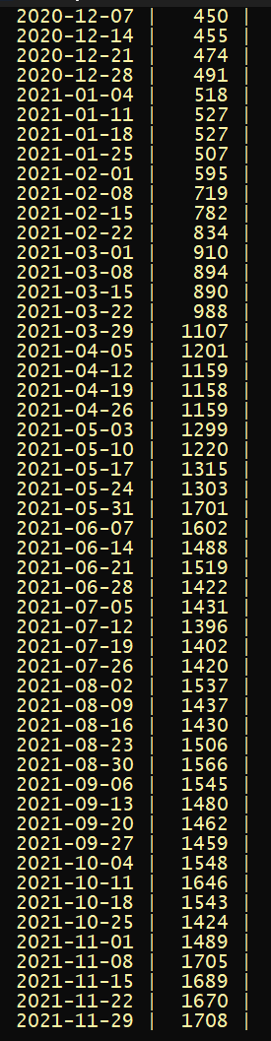

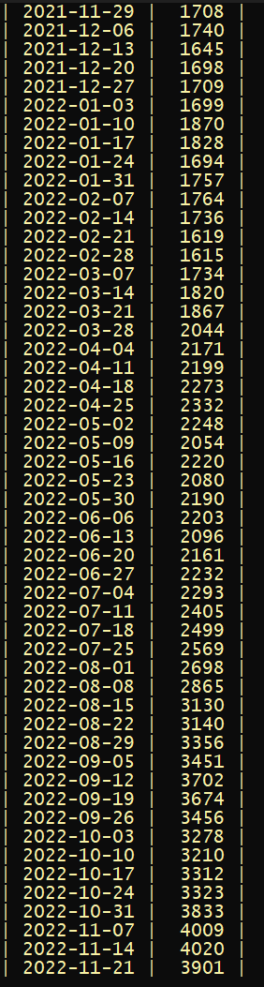 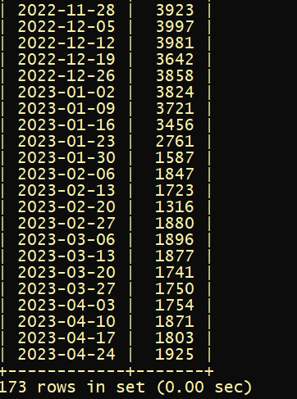

* **TABLE BUY**

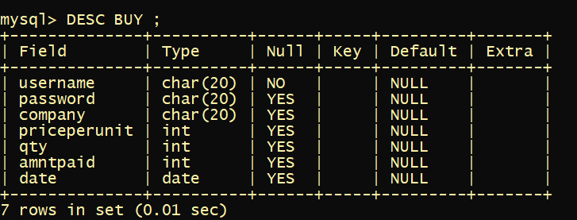

**SOURCE CODE**

**Code for company’s data entry**

**-------------------------reliance monthly----------------------------------**

**import mysql.connector**

**mydb = mysql.connector.connect(**

**host="localhost",**

**user="root",**

**password="2952007",**

**database="school_project",**

**auth_plugin=”mysql_native _password”**

**)**

**mycursor = mydb.cursor()**

**sql = "INSERT INTO reliance_monthly (date,price) VALUES (%s,%s)"**

**val = [**

**("2020-01-01",1398.4),**

**("2020-02-01",1316.2),**

**("2020-03-01",1103.3),**

**("2020-04-01",1452.2),**

**("2020-05-01",1464.4),**

**("2020-06-01",1704.1),**

**("2020-07-01",2067.1),**

**("2020-08-01",2080.7),**

**("2020-09-01",2234.4),**

**("2020-10-01",2054.5),**

**("2020-11-01",1929.8),**

**("2020-12-01",1985.3),**

**('2021-01-01',1841.9),**

**('2021-02-01',2085.8),**

**('2021-03-01',2003.1),**

**('2021-04-01',1994.5),**

**('2021-05-01',2160.3),**

**('2021-06-01',2110.6),**

**('2021-07-01',2035.3),**

**('2021-08-01',2258.1),**

**('2021-09-01',2519.3),**

**('2021-10-01',2536.3),**

**('2021-11-01',2405.4),**

**('2021-12-01',2368.1),**

**('2022-01-01',2386.6),**

**('2022-02-01',2359.6),**

**('2022-03-01',2634.8),**

**('2022-04-01',2790.3),**

**('2022-05-01',2632.6),**

**('2022-06-01',2595.6),**

**('2022-07-01',2509.4),**

**('2022-08-01',2637.9),**

**('2022-09-01',2377.8),**

**('2022-10-01',2549.6),**

**('2022-11-01',2731.4),**

**('2022-12-01',2547.2),**

**('2023-01-01',2353.9),**

**('2023-02-01',2322.6),**

**('2023-03-01',2331.1),**

**('2023-04-01',2336.4)**

**]**

**mycursor.executemany(sql, val)**

**mydb.commit()**

**print(mycursor.rowcount, "was inserted.")**

**-----------------------------------reliance weekly---------------------------------------**

**import mysql.connector**

**mydb = mysql.connector.connect(**

**host="localhost",**

**user="root",**

**password="2952007",**

**database="school_project",**

**auth_plugin=”mysql_native_password”**

**)**

**mycursor = mydb.cursor()**

**sql = "INSERT INTO reliance_weekly (date,price) VALUES (%s,%s)"**

**val = [**

**("2020-01-06", 1533),**

**("2020-01-13", 1566),**

**("2020-01-20", 1507),**

**("2020-01-27", 1370),**

**("2020-02-03", 1420),**

**("2020-02-10", 1474),**

**("2020-02-17", 1472),**

**("2020-02-24", 1316),**

**("2020-03-02", 1259),**

**("2020-03-09", 1095),**

**("2020-03-16", 1008),**

**("2020-03-23", 1056),**

**("2020-03-30", 1067),**

**("2020-04-06", 1208),**

**("2020-04-13", 1213),**

**("2020-04-20", 1404),**

**("2020-04-27", 1452),**

**("2020-05-04", 1547),**

**("2020-05-11", 1459),**

**("2020-05-18", 1432),**

**("2020-05-25", 1464),**

**("2020-06-01", 1582),**

**("2020-06-08", 1589),**

**("2020-06-15", 1759),**

**("2020-06-22", 1742),**

**("2020-06-29", 1788),**

**("2020-07-06", 1878),**

**("2020-07-13", 1912),**

**("2020-07-20", 2146),**

**("2020-07-27", 2067),**

**("2020-08-03", 2146),**

**("2020-08-10", 2114),**

**("2020-08-17", 2082),**

**("2020-08-24", 2116),**

**("2020-08-31", 2077),**

**("2020-09-07", 2320),**

**("2020-09-14", 2306),**

**("2020-09-21", 2202),**

**("2020-09-28", 2225),**

**("2020-10-05", 2233),**

**("2020-10-12", 2176),**

**("2020-10-19", 2113),**

**("2020-10-26", 2055),**

**("2020-11-02", 2029),**

**("2020-11-09", 2002),**

**("2020-11-16", 1900),**

**("2020-11-23", 1930),**

**("2020-11-30", 1947),**

**("2020-12-07", 2006),**

**("2020-12-14", 1992),**

**("2020-12-21", 1994),**

**("2020-12-28", 1988),**

**("2021-01-04", 1934),**

**("2021-01-11", 1937),**

**("2021-01-18", 2050),**

**("2021-01-25", 1842),**

**("2021-02-01", 1924),**

**("2021-02-08", 2042),**

**("2021-02-15", 2080),**

**("2021-02-22", 2086),**

**("2021-03-01", 2179),**

**("2021-03-08", 2138),**

**("2021-03-15", 2082),**

**("2021-03-22", 1995),**

**("2021-03-29", 2022),**

**("2021-04-05", 1982),**

**("2021-04-12", 1932),**

**("2021-04-19", 1904),**

**("2021-04-26", 1995),**

**("2021-05-03", 1932),**

**("2021-05-10", 1937),**

**("2021-05-17", 2003),**

**("2021-05-24", 2095),**

**("2021-05-31", 2191),**

**("2021-06-07", 2213),**

**("2021-06-14", 2226),**

**("2021-06-21", 2104),**

**("2021-06-28", 2129),**

**("2021-07-05", 2071),**

**("2021-07-12", 2112),**

**("2021-07-19", 2106),**

**("2021-07-26", 2035),**

**("2021-08-02", 2089),**

**("2021-08-09", 2146),**

**("2021-08-16", 2148),**

**("2021-08-23", 2227),**

**("2021-08-30", 2389),**

**("2021-09-06", 2426),**

**("2021-09-13", 2391),**

**("2021-09-20", 2483),**

**("2021-09-27", 2524),**

**("2021-10-04", 2671),**

**("2021-10-11", 2700),**

**("2021-10-18", 2627),**

**("2021-10-25", 2536),**

**("2021-11-01", 2499),**

**("2021-11-08", 2593),**

**("2021-11-15", 2473),**

**("2021-11-22", 2413),**

**("2021-11-29", 2408),**

**("2021-12-06", 2459),**

**("2021-12-13", 2340),**

**("2021-12-20", 2373),**

**("2021-12-27", 2368),**

**("2022-01-03", 2436),**

**("2022-01-10", 2539),**

**("2022-01-17", 2478),**

**("2022-01-24", 2336),**

**("2022-01-31", 2331),**

**("2022-02-07", 2376),**

**("2022-02-14", 2424),**

**("2022-02-21", 2284),**

**("2022-02-28", 2326),**

**("2022-03-07", 2399),**

**("2022-03-14", 2482),**

**("2022-03-21", 2596),**

**("2022-03-28", 2656),**

**("2022-04-04", 2616),**

**("2022-04-11", 2552),**

**("2022-04-18", 2759),**

**("2022-04-25", 2790),**

**("2022-05-02", 2621),**

**("2022-05-09", 2427),**

**("2022-05-16", 2624),**

**("2022-05-23", 2575),**

**("2022-05-30", 2780),**

**("2022-06-06", 2714),**

**("2022-06-13", 2590),**

**("2022-06-20", 2500),**

**("2022-06-27", 2409),**

**("2022-07-04", 2391),**

**("2022-07-11", 2402),**

**("2022-07-18", 2503),**

**("2022-07-25", 2509),**

**("2022-08-01", 2534),**

**("2022-08-08", 2633),**

**("2022-08-15", 2614),**

**("2022-08-22", 2618),**

**("2022-08-29", 2531),**

**("2022-09-05", 2569),**

**("2022-09-12", 2499),**

**("2022-09-19", 2440),**

**("2022-09-26", 2378),**

**("2022-10-03", 2432),**

**("2022-10-10", 2371),**

**("2022-10-17", 2472),**

**("2022-10-24", 2526),**

**("2022-10-31", 2593),**

**("2022-11-07", 2632),**

**("2022-11-14", 2598),**

**("2022-11-21", 2618),**

**("2022-11-28", 2722),**

**("2022-12-05", 2609),**

**("2022-12-12", 2566),**

**("2022-12-19", 2502),**

**("2022-12-26", 2547),**

**("2023-01-02", 2537),**

**("2023-01-09", 2468),**

**("2023-01-16", 2443),**

**("2023-01-23", 2337),**

**("2023-01-30", 2329),**

**("2023-02-06", 2337),**

**("2023-02-13", 2440),**

**("2023-02-20", 2384),**

**("2023-02-27", 2385),**

**("2023-03-06", 2323),**

**("2023-03-13", 2223),**

**("2023-03-20", 2203),**

**("2023-03-27", 2331),**

**("2023-04-03", 2341),**

**("2023-04-10", 2356),**

**("2023-04-17", 2349),**

**("2023-04-24", 2421)**

**]**

**mycursor.executemany(sql, val)**

**mydb.commit()**

**print(mycursor.rowcount, "was inserted.")**

**mycursor = mydb.cursor()**

**-------------------------------adani monthly--------------------------------------------**

**import mysql.connector**

**mydb = mysql.connector.connect(**

**host="localhost",**

**user="root",**

**password="2952007",**

**database="school_project",**

**auth_plugin="mysql_native_password"**

**)**

**mycursor = mydb.cursor()**

**sql = "INSERT INTO adani_monthly (date,price) VALUES (%s,%s)"**

**val = [**

**("2020-01-01", 229),**

**("2020-01-02", 219),**

**("2020-01-03", 138),**

**("2020-01-04", 141),**

**("2020-01-05", 148),**

**("2020-01-06", 156),**

**("2020-01-07", 175),**

**("2020-01-08", 280),**

**("2020-01-09", 297),**

**("2020-01-10", 340),**

**("2020-01-11", 398),**

**("2020-01-12", 480),**

**("2021-01-01", 507),**

**("2021-01-02", 834),**

**("2021-01-03", 1031),**

**("2021-01-04", 1159),**

**("2021-01-05", 1316),**

**("2021-01-06", 1508),**

**("2021-01-07", 1420),**

**("2021-01-08", 1588),**

**("2021-01-09", 1468),**

**("2021-01-10", 1424),**

**("2021-01-11", 1663),**

**("2021-01-12", 1709),**

**("2022-01-01", 1715),**

**("2022-01-02", 1644),**

**("2022-01-03", 2015),**

**("2022-01-04", 2332),**

**("2022-01-05", 2168),**

**("2022-01-06", 2191),**

**("2022-01-07", 2569),**

**("2022-01-08", 3194),**

**("2022-01-09", 3456),**

**("2022-01-10", 3347),**

**("2022-01-11", 3918),**

**("2022-01-12", 3858),**

**("2023-01-01", 2974),**

**("2023-01-02", 1364),**

**("2023-01-03", 1750),**

**("2023-01-04", 1851)**

**]**

**mycursor.executemany(sql, val)**

**mydb.commit()**

**print(mycursor.rowcount, "was inserted.")**

**-------------------------------adani weekly----------------------------------------------**

**import mysql.connector**

**mydb = mysql.connector.connect(**

**host="localhost",**

**user="root",**

**password="2952007",**

**database="school_project",**

**auth_plugin="mysql_native_password"**

**)**

**mycursor = mydb.cursor()**

**sql = "INSERT INTO adani_weekly (date,price) VALUES (%s,%s)"**

**val = [**

**("2020-01-06", 209),**

**("2020-01-13", 228),**

**("2020-01-20", 230),**

**("2020-01-27", 223),**

**("2020-02-03", 240),**

**("2020-02-10", 256),**

**("2020-02-17", 259),**

**("2020-02-24", 219),**

**("2020-03-02", 215),**

**("2020-03-09", 149),**

**("2020-03-16", 138),**

**("2020-03-23", 128),**

**("2020-03-30", 129),**

**("2020-04-06", 142),**

**("2020-04-13", 144),**

**("2020-04-20", 135),**

**("2020-04-27", 141),**

**("2020-05-04", 137),**

**("2020-05-11", 141),**

**("2020-05-18", 138),**

**("2020-05-25", 148),**

**("2020-06-01", 152),**

**("2020-06-08", 152),**

**("2020-06-15", 153),**

**("2020-06-22", 162),**

**("2020-06-29", 160),**

**("2020-07-06", 160),**

**("2020-07-13", 152),**

**("2020-07-20", 169),**

**("2020-07-27", 175),**

**("2020-08-03", 193),**

**("2020-08-10", 196),**

**("2020-08-17", 233),**

**("2020-08-24", 288),**

**("2020-08-31", 285),**

**("2020-09-07", 296),**

**("2020-09-14", 292),**

**("2020-09-21", 280),**

**("2020-09-28", 308),**

**("2020-10-05", 313),**

**("2020-10-12", 307),**

**("2020-10-19", 315),**

**("2020-10-26", 340),**

**("2020-11-02", 352),**

**("2020-11-09", 371),**

**("2020-11-16", 388),**

**("2020-11-23", 398),**

**("2020-11-30", 446),**

**("2020-12-07", 450),**

**("2020-12-14", 455),**

**("2020-12-21", 474),**

**("2020-12-28", 491),**

**("2021-01-04", 518),**

**("2021-01-11", 527),**

**("2021-01-18", 527),**

**("2021-01-25", 507),**

**("2021-02-01", 595),**

**("2021-02-08", 719),**

**("2021-02-15", 782),**

**("2021-02-22", 834),**

**("2021-03-01", 910),**

**("2021-03-08", 894),**

**("2021-03-15", 890),**

**("2021-03-22", 988),**

**("2021-03-29", 1107),**

**("2021-04-05", 1201),**

**("2021-04-12", 1159),**

**("2021-04-19", 1158),**

**("2021-04-26", 1159),**

**("2021-05-03", 1299),**

**("2021-05-10", 1220),**

**("2021-05-17", 1315),**

**("2021-05-24", 1303),**

**("2021-05-31", 1701),**

**("2021-06-07", 1602),**

**("2021-06-14", 1488),**

**("2021-06-21", 1519),**

**("2021-06-28", 1422),**

**("2021-07-05", 1431),**

**("2021-07-12", 1396),**

**("2021-07-19", 1402),**

**("2021-07-26", 1420),**

**("2021-08-02", 1537),**

**("2021-08-09", 1437),**

**("2021-08-16", 1430),**

**("2021-08-23", 1506),**

**("2021-08-30", 1566),**

**("2021-09-06", 1545),**

**("2021-09-13", 1480),**

**("2021-09-20", 1462),**

**("2021-09-27", 1459),**

**("2021-10-04", 1548),**

**("2021-10-11", 1646),**

**("2021-10-18", 1543),**

**("2021-10-25", 1424),**

**("2021-11-01", 1489),**

**("2021-11-08", 1705),**

**("2021-11-15", 1689),**

**("2021-11-22", 1670),**

**("2021-11-29", 1708),**

**("2021-12-06", 1740),**

**("2021-12-13", 1645),**

**("2021-12-20", 1698),**

**("2021-12-27", 1709),**

**("2022-01-03", 1699),**

**("2022-01-10", 1870),**

**("2022-01-17", 1828),**

**("2022-01-24", 1694),**

**("2022-01-31", 1757),**

**("2022-02-07", 1764),**

**("2022-02-14", 1736),**

**("2022-02-21", 1619),**

**("2022-02-28", 1615),**

**("2022-03-07", 1734),**

**("2022-03-14", 1820),**

**("2022-03-21", 1867),**

**("2022-03-28", 2044),**

**("2022-04-04", 2171),**

**("2022-04-11", 2199),**

**("2022-04-18", 2273),**

**("2022-04-25", 2332),**

**("2022-05-02", 2248),**

**("2022-05-09", 2054),**

**("2022-05-16", 2220),**

**("2022-05-23", 2080),**

**("2022-05-30", 2190),**

**("2022-06-06", 2203),**

**("2022-06-13", 2096),**

**("2022-06-20", 2161),**

**("2022-06-27", 2232),**

**("2022-07-04", 2293),**

**("2022-07-11", 2405),**

**("2022-07-18", 2499),**

**("2022-07-25", 2569),**

**("2022-08-01", 2698),**

**("2022-08-08", 2865),**

**("2022-08-15", 3130),**

**("2022-08-22", 3140),**

**("2022-08-29", 3356),**

**("2022-09-05", 3451),**

**("2022-09-12", 3702),**

**("2022-09-19", 3674),**

**("2022-09-26", 3456),**

**("2022-10-03", 3278),**

**("2022-10-10", 3210),**

**("2022-10-17", 3312),**

**("2022-10-24", 3323),**

**("2022-10-31", 3833),**

**("2022-11-07", 4009),**

**("2022-11-14", 4020),**

**("2022-11-21", 3901),**

**("2022-11-28", 3923),**

**("2022-12-05", 3997),**

**("2022-12-12", 3981),**

**("2022-12-19", 3642),**

**("2022-12-26", 3858),**

**("2023-01-02", 3824),**

**("2023-01-09", 3721),**

**("2023-01-16", 3456),**

**("2023-01-23", 2761),**

**("2023-01-30", 1587),**

**("2023-02-06", 1847),**

**("2023-02-13", 1723),**

**("2023-02-20", 1316),**

**("2023-02-27", 1880),**

**("2023-03-06", 1896),**

**("2023-03-13", 1877),**

**("2023-03-20", 1741),**

**("2023-03-27", 1750),**

**("2023-04-03", 1754),**

**("2023-04-10", 1871),**

**("2023-04-17", 1803),**

**("2023-04-24", 1925)**

**]**

**mycursor.executemany(sql, val)**

**mydb.commit()**

**print(mycursor.rowcount, "was inserted.")**

**--------------------------------------USER INTERFACE------------------------------**

**# WELCOME WINDOW**

**# importing libraries**

**from tkinter import \***

**from PIL import ImageTk,Image**

**# defining commands**

**def proceed():**

**welcome_window.destroy()**

**import sign**

**#create welcome window**

**welcome_window = Tk()**

**welcome_window.title('WELCOME WINDOW')**

**welcome_window.geometry("1535x835")**

**welcome_window.resizable(0,0)**

**LBACK=ImageTk.PhotoImage(Image.open("Untitled.jpg"))**

**BACK=Label(welcome_window,image=LBACK)**

**BACK.place(x=0,y=0)**

**#bgimage**

**# proceed**

**proceedButton=Button(welcome_window,text="PROCEED⇒",command=proceed,font=("Times",20,"bold"),bg="purple4",fg="white",bd=8)**

**proceedButton.place(x=1310,y=765)**

**welcome_window.mainloop()**

**---------------------------------------------------------------------------------------------**

**# SIGNUP WINDOW**

**# importing liabraries**

**from tkinter import \***

**from PIL import ImageTk,Image**

**import mysql.connector**

**from tkinter import messagebox**

**# defining**

**def signup():**

**if usernameEntry.get()=="" or passwordEntry.get()=="" or phoneEntry.get()=="":**

**messagebox.showerror('ERROR','INSERT ALL DETAILS')**

**else:**

**myconn=mysql.connector.connect(host="localhost",user="root",passwd="2952007",database="school_project",auth_plugin="mysql_native_password")**

**c=myconn.cursor(buffered=True)**

**query="INSERT INTO LOGIN (username,password,phone_no) VALUES (%s,%s,%s)"**

**c.execute(query,(usernameEntry.get(),passwordEntry.get(),phoneEntry.get()))**

**myconn.commit()**

**myconn.close()**

**messagebox.showinfo('success','successful')**

**signup_window.destroy()**

**import access**

**def alreadyhaveanacc( ):**

**signup_window.destroy()**

**import login**

**# create signup window**

**signup_window=Tk()**

**signup_window.title("SIGNUP_WINDOW")**

**signup_window.configure(bg="purple4")**

**signup_window.geometry("1535x835")**

**signup_window.resizable(0,0)**

**# importing imgs**

**LBACK=ImageTk.PhotoImage(Image.open("sign.jpg"))**

**BACK=Label(signup_window,image=LBACK)**

**BACK.place(x=0,y=0)**

**background=ImageTk.PhotoImage(file=("logins.jpg"))**

**bglabel=Label(signup_window,image=background)**

**bglabel.place(x=50,y=100)**

**# GUI CONTENT ⇣**

**# LABELS AND ENTRY BOX**

**usernamelabel=Label(signup_window,text="USERNAME:",font=("times",20,"bold"),bg="white",fg="black")**

**usernamelabel.place(x=980,y=170)**

**usernameEntry=Entry(signup_window,width=31,font=("Times",20,"bold"),bg="WHITE",fg="black",bd=0)**

**usernameEntry.place(x=980,y=210)**

**frame1=Frame(signup_window,bg='black',width=435,height=2).place(x=980,y=241)**

**passwordlabel=Label(signup_window,text="PASSWORD:",font=("Times",20,"bold"),bg="white",fg="black")**

**passwordlabel.place(x=980,y=285)**

**passwordEntry=Entry(signup_window,width=31,font=("Times",20,"bold"),bg="white",fg="black",bd=0,show="*")**

**passwordEntry.place(x=980,y=325)**

**frame2=Frame(signup_window,bg='black',width=435,height=2).place(x=980,y=355)**

**phonelabel=Label(signup_window,text="PHONE NO.",font=("Times",20,"bold"),bg="white",fg="black")**

**phonelabel.place(x=980,y=410)**

**phoneEntry=Entry(signup_window,width=31,font=("Times",20,"bold"),fg="black",bd=0)**

**phoneEntry.place(x=980,y=450)**

**frame3=Frame(signup_window,bg='black',width=435,height=2).place(x=980,y=480)**

**# BUTTONS**

**signupbutton=Button(signup_window,text="SIGN UP",width=20,bg="dodger blue2",font=("Times",20,"bold"),command=signup,foreground="white",bd=8)**

**signupbutton.place(x=1050,y=550)**

**already_have_an_account=Button(signup_window,text="already_have_an_account",command=alreadyhaveanacc,bg="white",fg="red",bd=8,font=("Times",20,"bold"),width=22)**

**already_have_an_account.place(x=1041,y=640)**

**signup_window.mainloop()**

**--------------------------------------------------------------------------------------------**

**# LOGIN WINDOW**

**#importing liabraries**

**from tkinter import \***

**from PIL import Image,ImageTk**

**from tkinter import messagebox**

**import mysql.connector**

**# defining commands**

**def donthaveanacc():**

**login_window.destroy()**

**import sign**

**def login():**

**if usernameentry.get()=="" or passwordentry.get()=="" :**

**messagebox.showerror('ERROR','INSERT ALL DETAILS')**

**else:**

**myconn=mysql.connector.connect(host="localhost",user="root",passwd="2952007",database="school_project",auth_plugin="mysql_native_password")**

**c=myconn.cursor(buffered=True)**

**uname=usernameentry.get()**

**passw=passwordentry.get()**

**query = "SELECT username ,password FROM login WHERE username = %s and password=%s"**

**c.execute(query, [(uname),(passw)])**

**ce=c.fetchall()**

**if ce == NONE :**

**messagebox.showerror('ERROR','INVALID DETAILS :<')**

**elif ce:**

**messagebox.showinfo('WELCOME','LOGIN SUCCESSFUL ^_^')**

**login_window.destroy()**

**import access**

**else:**

**messagebox.showerror('ERROR','INVALID DETAILS ＞︿＜')**

**# create login window**

**login_window=Tk()**

**login_window.title("LOGIN_WINDOW")**

**login_window.configure(bg="purple4")**

**login_window.geometry("1535x835")**

**login_window.resizable(0,0)**

**# importing imgs**

**LBACK=ImageTk.PhotoImage(Image.open("LOGIN.jpg"))**

**BACK=Label(login_window,image=LBACK)**

**BACK.place(x=0,y=0)**

**logimage=ImageTk.PhotoImage(Image.open("logins.jpg"))**

**logLabel=Label(login_window,image=logimage)**

**logLabel.place(x=20,y=110)**

**# GUI CONTENT ⇣**

**#LABELS AND ENTRY BOX**

**username=Label(login_window,text="USERNAME:",font=("Times",20,"bold"),bg="white",fg="black")**

**username.place(x=980,y=165)**

**usernameentry=Entry(login_window,width=31,font=("Times",20,"bold"),bg="white",fg="black",bd=0)**

**usernameentry.place(x=980,y=210)**

**frame1=Frame(login_window,bg='black',width=435,height=2).place(x=980,y=240)**

**password=Label(login_window,text="PASSWORD:",font=("Times",20,"bold"),bg="white",fg="black")**

**password.place(x=980,y=282)**

**passwordentry=Entry(login_window,width=31,font=("Times",20,"bold"),bg="white",fg="black",bd=0,show="*")**

**passwordentry.place(x=980,y=325)**

**frame2=Frame(login_window,bg='black',width=435,height=2).place(x=980,y=355)**

**# BUTTONS**

**login=Button(login_window,text="LOGIN",font=("Times",20,"bold"),bg="dodger blue2",fg="white",width=20,command=login,foreground="white",bd=8)**

**login.place(x=980,y=550)**

**dont_have_an_account=Button(login_window,text="create_account",command=donthaveanacc,bg="white",fg="red",bd=8,font=("Times",20,"bold"),width=22)**

**dont_have_an_account.place(x=960,y=640)**

**login_window.mainloop()**

**---------------------------------------------------------------------------------------------**

**# ACCESS WINDOW**

**#importing libraries**

**from tkinter import \***

**from PIL import Image,ImageTk**

**# definig commands**

**def new():**

**access_window.destroy()**

**import intro**

**def graphwin():**

**access_window.destroy()**

**import graph**

**def buywin():**

**access_window.destroy()**

**import buywindow**

**def port():**

**access_window.destroy()**

**import portfolio**

**# creating window**

**access_window=Tk()**

**access_window.geometry('1535x835')**

**access_window.resizable(0,0)**

**access_window.config(bg='sea green')**

**access_window.title('ACCESS WINDOW')**

**# inserting imgs**

**logimage=ImageTk.PhotoImage(Image.open("BACK2.jpeg"))**

**logLabel=Label(access_window,image=logimage).place(x=0,y=0)**

**graphimg=ImageTk.PhotoImage(Image.open("stock m.jpg"))**

**graphh=Label(access_window,image=graphimg,bd=0).place(x=450,y=100)**

**# GUI CONTENT ⇣**

**#labels**

**wintitle=Label(access_window,text=' ACCESS WINDOW ',font=('times',35,'bold'),bg='seagreen',fg='white',bd=8)**

**wintitle.place(x=550,y=0)**

**# buttons**

**newbie=Button(access_window,text='NEWBIE',width=25,bg='purple4',fg='white',font=('times',20,'bold'),bd=8,command= new)**

**newbie.place(x=0,y=150)**

**graph=Button(access_window,text='GRAPHS ',bg='purple4',width=25,fg='white',font=('times',20,'bold'),bd=8,command=graphwin)**

**graph.place(x=0,y=250)**

**buystock=Button(access_window,text='BUY STOCKS',bg='purple4',width=25,fg='white',font=('times',20,'bold'),bd=8,command=buywin)**

**buystock.place(x=0,y=350)**

**mngstock=Button(access_window,text='MANAGE STOCKS ',width=25,bg='purple4',fg='white',font=('times',20,'bold'),bd=8,command=port)**

**mngstock.place(x=0,y=450)**

**access_window.mainloop()**

**---------------------------------------------------------------------------------------------**

**# INTRO WINDOW**

**#importing libraries**

**from tkinter import \***

**from PIL import Image,ImageTk**

**# defining commands**

**def proceed():**

**intro_window.destroy()**

**import sgraph**

**# create intro window**

**intro_window=Tk()**

**intro_window.geometry("1535x835")**

**intro_window.title("INTRODUCTION")**

**intro_window.resizable(0,0)**

**intro_window.config(bg="black")**

**# importing imgs**

**bb=ImageTk.PhotoImage(Image.open("intro.jpg"))**

**bbLabel=Label(intro_window,image=bb,bd=0)**

**bbLabel.place(x=0,y=0)**

**# proceed button**

**proceedButton=Button(intro_window,text="PROCEED⇒",command=proceed,font="times,10,bold",width=15,bg="purple4",fg="white",bd=0)**

**proceedButton.place(x=1360,y=795)**

**intro_window.mainloop()**

**--------------------------------------------------------------------------------------------- # SAMPLEGRAPH WINDOW**

**#importing libraries**

**from tkinter import \***

**from PIL import Image,ImageTk**

**# defining commands**

**def proceed():**

**sgraph_window.destroy()**

**import graph**

**# create intro window**

**sgraph_window=Tk()**

**sgraph_window.geometry("1535x835")**

**sgraph_window.title("SAMPLE GRAPH")**

**sgraph_window.resizable(0,0)**

**sgraph_window.config(bg="black")**

**# importing imgs**

**bb=ImageTk.PhotoImage(Image.open("sgraph.jpg"))**

**bbLabel=Label(sgraph_window,image=bb,bd=0)**

**bbLabel.place(x=0,y=0)**

**wintitle=Label(sgraph_window,text=' SAMPLE GRAPH ',font=('times',35,'bold'),bg='seagreen',fg='white',bd=8)**

**wintitle.place(x=550,y=0)**

**# proceed button**

**proceedButton=Button(sgraph_window,text="PROCEED⇒",command=proceed,font="times,10,bold",width=15,bg="purple4",fg="white",bd=0)**

**proceedButton.place(x=1360,y=795)**

**sgraph_window.mainloop()**

**# GRAPH_WINDOW**

**#GRAPH_WINDOW**

**# importing libraries**

**from tkinter import \***

**import matplotlib.pyplot as plt**

**import mysql.connector as sqltor**

**import pandas as pd**

**from PIL import ImageTk,Image**

**# definig commands**

**def BUY():**

**graph_window.destroy()**

**import buywindow**

**#connecting mysql and python**

**mycon=sqltor.connect(host="localhost", user="root", passwd="2952007", database="school_project",auth_plugin="mysql_native_password")**

**if mycon.is_connected():**

**reliance_monthly=pd.read_sql("select*from reliance_monthly",mycon)**

**tata_monthly=pd.read_sql("select*from tata_monthly",mycon)**

**adani_monthly=pd.read_sql("select*from adani_monthly",mycon)**

**hdfc_monthly=pd.read_sql("select*from hdfc_monthly",mycon)**

**infosys_monthly=pd.read_sql("select*from infosys_monthly",mycon)**

**itc_monthly=pd.read_sql("select*from itc_monthly",mycon)**

**sbi_monthly=pd.read_sql("select*from sbi_monthly",mycon)**

**# now weekly**

**reliance_weekly=pd.read_sql("select*from reliance_weekly",mycon)**

**tata_weekly=pd.read_sql("select*from tata_weekly",mycon)**

**adani_weekly=pd.read_sql("select*from adani_weekly",mycon)**

**hdfc_weekly=pd.read_sql("select*from hdfc_weekly",mycon)**

**infosys_weekly=pd.read_sql("select*from infosys_weekly",mycon)**

**itc_weekly=pd.read_sql("select*from itc_weekly",mycon)**

**sbi_weekly=pd.read_sql("select*from sbi_weekly",mycon)**

**# code for graphs**

**# for reliance**

**def reliance_graph_monthly():**

**plt.plot(reliance_monthly['date'],reliance_monthly['price'])**

**#fi(reliance_monthly['date'],reliance_monthly['price'], color='blue', alpha=0.3)**

**plt.xlabel('Date(in months)')**

**manager = plt.get_current_fig_manager()**

**manager.full_screen_toggle()**

**plt.ylabel('Stock Price')**

**plt.title('Reliance_Monthly')**

**plt.show()**

**def reliance_graph_weekly():**

**plt.plot(reliance_weekly['date'],reliance_weekly['price'])**

**#fill cekly['date'],reliance_weekly['price'], color='blue', alpha=0.3)**

**plt.xlabel('Date(in weeks)')**

**manager = plt.get_current_fig_manager()**

**manager.full_screen_toggle()**

**plt.ylabel('Stock Price')**

**plt.title('Reliance_Weekly')**

**plt.show()**

**#for Tata**

**def tata_graph_monthly():**

**plt.plot(tata_monthly['date'],tata_monthly['price'])**

**#fill color**

**plt.xlabel('Date(in months)')**

**manager = plt.get_current_fig_manager()**

**manager.full_screen_toggle()**

**plt.ylabel('Stock Price')**

**plt.title('Tata_Monthly')**

**plt.show()**

**def tata_graph_weekly():**

**plt.plot(tata_weekly['date'],tata_weekly['price'])**

**#fill colorr='red', alpha=0.3)**

**plt.xlabel('Date(in weeks)')**

**manager = plt.get_current_fig_manager()**

**manager.full_screen_toggle()**

**plt.ylabel('Stock Price')**

**plt.title('Tata_Weekly')**

**plt.show()**

**# for Adani**

**def adani_graph_monthly():**

**plt.plot(adani_monthly['date'],adani_monthly['price'])**

**#fill color**

**plt.xlabel('Date(in months)')**

**plt.ylabel('Stock Price')**

**plt.title('Adani_Monthly')**

**manager = plt.get_current_fig_manager()**

**manager.full_screen_toggle()**

**plt.show()**

**def adani_graph_weekly():**

**plt.plot(adani_weekly['date'],adani_weekly['price'])**

**#fill color**

**plt.xlabel('Date(in weeks)')**

**manager = plt.get_current_fig_manager()**

**manager.full_screen_toggle()**

**plt.ylabel('Stock Price')**

**plt.title('Adani_Weekly')**

**plt.show()**

**# for hdfc**

**def hdfc_graph_monthly():**

**plt.plot(hdfc_monthly['date'],hdfc_monthly['price'])**

**plt.xlabel('Date(in months)')**

**plt.ylabel('Stock Price')**

**plt.title('Hdfc_Monthly')**

**manager = plt.get_current_fig_manager()**

**manager.full_screen_toggle()**

**plt.show()**

**def hdfc_graph_weekly():**

**plt.plot(hdfc_weekly['date'],hdfc_weekly['price'])**

**#fill col**

**plt.xlabel('Date(in weeks)')**

**manager = plt.get_current_fig_manager()**

**manager.full_screen_toggle()**

**plt.ylabel('Stock Price')**

**plt.title('Hdfc_Weekly')**

**plt.show()**

**# for infosys**

**def infosys_graph_monthly():**

**plt.plot(infosys_monthly['date'],infosys_monthly['price'])**

**#fill color**

**plt.xlabel('Date(in months)')**

**plt.ylabel('Stock Price')**

**plt.title('Infosys_Monthly')**

**manager = plt.get_current_fig_manager()**

**manager.full_screen_toggle()**

**plt.show()**

**def infosys_graph_weekly():**

**plt.plot(infosys_weekly['date'],infosys_weekly['price'])**

**#fill colo**

**plt.xlabel('Date(in weeks)')**

**manager = plt.get_current_fig_manager()**

**manager.full_screen_toggle()**

**plt.ylabel('Stock Price')**

**plt.title('Infosys_Weekly')**

**plt.show()**

**#for itc**

**def itc_graph_monthly():**

**plt.plot(itc_monthly['date'],itc_monthly['price'])**

**#fill color**

**plt.xlabel('Date(in months)')**

**plt.ylabel('ITC_Monthly')**

**plt.title('')**

**manager = plt.get_current_fig_manager()**

**manager.full_screen_toggle()**

**plt.show()**

**def itc_graph_weekly():**

**plt.plot(itc_weekly['date'],itc_weekly['price'])**

**#fill color**

**plt.xlabel('Date(in weeks)')**

**manager = plt.get_current_fig_manager()**

**manager.full_screen_toggle()**

**plt.ylabel('Stock Price')**

**plt.title('ITC_Weekly')**

**plt.show()**

**#for sbi**

**def sbi_graph_monthly():**

**plt.plot(sbi_monthly['date'],sbi_monthly['price'])**

**#fill color**

**plt.xlabel('Date(in months)')**

**plt.ylabel('Stock Price')**

**plt.title('SBI_Monthly')**

**manager = plt.get_current_fig_manager()**

**manager.full_screen_toggle()**

**plt.show()**

**def sbi_graph_weekly():**

**plt.plot(sbi_weekly['date'],sbi_weekly['price'])**

**#fill color**

**plt.xlabel('Date(in weeks)')**

**manager = plt.get_current_fig_manager()**

**manager.full_screen_toggle()**

**plt.ylabel('Stock Price')**

**plt.title('SBI_Weekly')**

**plt.show()**

**# working of menu3 (duration)**

**def brand1():**

**selected_time1=menu3.get()**

**if selected_time1=="MONTHLY":**

**selected_company1=menu1.get()**

**if selected_company1=="RELIANCE":**

**reliance_graph_monthly()**

**elif selected_company1=="TATA MOTORS":**

**tata_graph_monthly()**

**elif selected_company1=="ADANI":**

**adani_graph_monthly()**

**elif selected_company1=="HDFC BANK":**

**hdfc_graph_monthly()**

**elif selected_company1=="INFOSYS":**

**infosys_graph_monthly()**

**elif selected_company1=="ITC":**

**itc_graph_monthly()**

**elif selected_company1=="SBI":**

**sbi_graph_monthly()**

**# weekly**

**elif selected_time1=="WEEKLY":**

**selected_company1=menu1.get()**

**if selected_company1=="RELIANCE":**

**reliance_graph_weekly()**

**elif selected_company1=="TATA MOTORS":**

**tata_graph_weekly()**

**elif selected_company1=="ADANI":**

**adani_graph_weekly()**

**elif selected_company1=="HDFC BANK":**

**hdfc_graph_weekly()**

**elif selected_company1=="INFOSYS":**

**infosys_graph_weekly()**

**elif selected_company1=="ITC":**

**itc_graph_weekly()**

**elif selected_company1=="SBI":**

**sbi_graph_weekly()**

**# working of menu 4 (duration)**

**def brand2():**

**selected_time2=menu4.get()**

**if selected_time2=="MONTHLY":**

**selected_company2=menu2.get()**

**if selected_company2=="RELIANCE":**

**reliance_graph_monthly()**

**elif selected_company2=="TATA MOTORS":**

**tata_graph_monthly()**

**elif selected_company2=="ADANI":**

**adani_graph_monthly()**

**elif selected_company2=="HDFC BANK":**

**hdfc_graph_monthly()**

**elif selected_company2=="INFOSYS":**

**infosys_graph_monthly()**

**elif selected_company2=="ITC":**

**itc_graph_monthly()**

**elif selected_company2=="SBI":**

**sbi_graph_monthly()**

**# weekly**

**elif selected_time2=="WEEKLY":**

**selected_company2=menu2.get()**

**if selected_company2=="RELIANCE":**

**reliance_graph_weekly()**

**elif selected_company2=="TATA MOTORS":**

**tata_graph_weekly()**

**elif selected_company2=="ADANI":**

**adani_graph_weekly()**

**elif selected_company2=="HDFC BANK":**

**hdfc_graph_weekly()**

**elif selected_company2=="INFOSYS":**

**infosys_graph_weekly()**

**elif selected_company2=="ITC":**

**itc_graph_weekly()**

**elif selected_company2=="SBI":**

**sbi_graph_weekly()**

**# working of compare (displays combine graph of selected companies)**

**def compare():**

**selected_company1 = menu1.get()**

**selected_company2 = menu2.get()**

**if menu3.get() == "MONTHLY" and menu4.get() == "MONTHLY":**

**if selected_company1 == "RELIANCE":**

**name = reliance_monthly**

**elif selected_company1 == "TATA MOTORS":**

**name = tata_monthly**

**elif selected_company1 == "ADANI":**

**name = adani_monthly**

**elif selected_company1 == "HDFC BANK":**

**name = hdfc_monthly**

**elif selected_company1 == "INFOSYS":**

**name = infosys_monthly**

**elif selected_company1 == "ITC":**

**name = itc_monthly**

**else:**

**name = sbi_monthly**

**if selected_company2 == "RELIANCE":**

**name2 = reliance_monthly**

**elif selected_company2 == "TATA MOTORS":**

**name2 = tata_monthly**

**elif selected_company2 == "ADANI":**

**name2 = adani_monthly**

**elif selected_company2 == "HDFC BANK":**

**name2 = hdfc_monthly**

**elif selected_company2 == "INFOSYS":**

**name2 = infosys_monthly**

**elif selected_company2 == "ITC":**

**name2 = itc_monthly**

**else:**

**name2 = sbi_monthly**

**# plotting both graphs**

**plt.plot(name['date'], name['price'],label=selected_company1)**

**plt.plot(name2['date'], name2['price'],label=selected_company2)**

**plt.xlabel('Date(in months)')**

**plt.ylabel('Stock Price')**

**plt.title('COMPARISON BETWEEN TWO COMPANIES')**

**manager = plt.get_current_fig_manager()**

**manager.full_screen_toggle()**

**plt.legend(loc="upper right")**

**plt.show()**

**if menu3.get() == "WEEKLY" and menu4.get() == "MONTHLY":**

**if selected_company1 == "RELIANCE":**

**name = reliance_weekly**

**elif selected_company1 == "TATA MOTORS":**

**name = tata_weekly**

**elif selected_company1 == "ADANI":**

**name = adani_weekly**

**elif selected_company1 == "HDFC BANK":**

**name = hdfc_weekly**

**elif selected_company1 == "INFOSYS":**

**name = infosys_weekly**

**elif selected_company1 == "ITC":**

**name = itc_weekly**

**else:**

**name = sbi_weekly**

**if selected_company2 == "RELIANCE":**

**name2 = reliance_monthly**

**elif selected_company2 == "TATA MOTORS":**

**name2 = tata_monthly**

**elif selected_company2 == "ADANI":**

**name2 = adani_monthly**

**elif selected_company2 == "HDFC BANK":**

**name2 = hdfc_monthly**

**elif selected_company2 == "INFOSYS":**

**name2 = infosys_monthly**

**elif selected_company2 == "ITC":**

**name2 = itc_monthly**

**else:**

**name2 = sbi_monthly**

**# plotting both graphs**

**plt.plot(name['date'], name['price'],label=selected_company1)**

**plt.plot(name2['date'], name2['price'],label=selected_company2)**

**plt.xlabel('Date(in months)')**

**plt.ylabel('Stock Price')**

**#fill color**

**plt.legend()**

**plt.title('COMPARISON BETWEEN TWO COMPANIES')**

**manager = plt.get_current_fig_manager()**

**manager.full_screen_toggle()**

**plt.legend(loc="upper right")**

**plt.show()**

**if menu3.get() == "MONTHLY" and menu4.get() == "WEEKLY":**

**if selected_company1 == "RELIANCE":**

**name = reliance_monthly**

**elif selected_company1 == "TATA MOTORS":**

**name = tata_monthly**

**elif selected_company1 == "ADANI":**

**name = adani_monthly**

**elif selected_company1 == "HDFC BANK":**

**name = hdfc_monthly**

**elif selected_company1 == "INFOSYS":**

**name = infosys_monthly**

**elif selected_company1 == "ITC":**

**name = itc_monthly**

**else:**

**name = sbi_monthly**

**if selected_company2 == "RELIANCE":**

**name2 = reliance_weekly**

**elif selected_company2 == "TATA MOTORS":**

**name2 = tata_weekly**

**elif selected_company2 == "ADANI":**

**name2 = adani_weekly**

**elif selected_company2 == "HDFC BANK":**

**name2 = hdfc_weekly**

**elif selected_company2 == "INFOSYS":**

**name2 = infosys_weekly**

**elif selected_company2 == "ITC":**

**name2 = itc_weekly**

**else:**

**name2 = sbi_weekly**

**# plotting both graphs**

**plt.plot(name['date'], name['price'],label=selected_company1)**

**plt.plot(name2['date'], name2['price'],label=selected_company2)**

**plt.xlabel('Date(in weeks)')**

**plt.ylabel('Stock Price')**

**#fill color**

**plt.title('COMPARISON BETWEEN TWO COMPANIES')**

**manager = plt.get_current_fig_manager()**

**manager.full_screen_toggle()**

**plt.legend(loc="upper right")**

**plt.show()**

**if menu3.get() == "WEEKLY" and menu4.get() == "WEEKLY":**

**if selected_company1 == "RELIANCE":**

**name = reliance_weekly**

**elif selected_company1 == "TATA MOTORS":**

**name = tata_weekly**

**elif selected_company1 == "ADANI":**

**name = adani_weekly**

**elif selected_company1 == "HDFC BANK":**

**name = hdfc_weekly**

**elif selected_company1 == "INFOSYS":**

**name = infosys_weekly**

**elif selected_company1 == "ITC":**

**name = itc_weekly**

**else:**

**name = sbi_weekly**

**if selected_company2 == "RELIANCE":**

**name2 = reliance_weekly**

**elif selected_company2 == "TATA MOTORS":**

**name2 = tata_weekly**

**elif selected_company2 == "ADANI":**

**name2 = adani_weekly**

**elif selected_company2 == "HDFC BANK":**

**name2 = hdfc_weekly**

**elif selected_company2 == "INFOSYS":**

**name2 = infosys_weekly**

**elif selected_company2 == "ITC":**

**name2 = itc_weekly**

**else:**

**name2 = sbi_weekly**

**# plotting both gr**

**plt.plot(name['date'], name['price'],label=selected_company1)**

**plt.plot(name2['date'], name2['price'],label=selected_company2)**

**plt.xlabel('Date(in weeks)')**

**plt.ylabel('Stock Price')**

**#fill color**

**plt.title('COMPARISON BETWEEN TWO COMPANIES')**

**manager = plt.get_current_fig_manager()**

**manager.full_screen_toggle()**

**plt.legend(loc="upper right")**

**plt.show()**

**# main graph_window**

**graph_window = Tk()**

**graph_window.title("Graph of several companies")**

**graph_window.geometry("1535x835")**

**LBACK=ImageTk.PhotoImage(Image.open("BACK2 - Copy.jpg"))**

**BACK=Label(graph_window,image=LBACK)**

**BACK.place(x=0,y=0)**

**# GUI CONTENT ⇣**

**# drop down for selecting companies**

**menu1=StringVar()**

**menu1.set("COMPANY 1")**

**drop1=OptionMenu(graph_window,menu1,"RELIANCE","TATA MOTORS","ADANI","HDFC BANK","INFOSYS","ITC","SBI")**

**drop1.config(font=('times',18,'bold'))**

**drop1.place(x="500",y="235")**

**menu2=StringVar()**

**menu2.set("COMPANY 2")**

**drop2=OptionMenu(graph_window,menu2,"RELIANCE","TATA MOTORS","ADANI","HDFC BANK","INFOSYS","ITC","SBI")**

**drop2.config(font=('times',18,"bold"))**

**drop2.place(x=1000,y=235)**

**# dropdown for duration**

**menu3=StringVar()**

**menu3.set("Select Duration")**

**drop3=OptionMenu(graph_window,menu3,"MONTHLY","WEEKLY")**

**drop3.config(font=('times',18,'bold'))**

**drop3.place(x=500,y=330)**

**menu4=StringVar()**

**menu4.set("Select Duration")**

**drop4=OptionMenu(graph_window,menu4,"MONTHLY","WEEKLY")**

**drop4.config(font=("times",18,'bold'))**

**drop4.place(x=1000,y=330)**

**# buttons**

**graph1=Button(graph_window,text="Graph ",command=lambda: brand1(),width=15,height=1,bd=5)**

**graph1.place(x=500,y=435)**

**graph1.config(fg="black",font=('times',18,"bold"))**

**graph2=Button(graph_window,text="Graph",command=lambda: brand2(),width=15,font=("times",18,"bold"),bd=5)**

**graph2.place(x=1000,y=435)**

**graph2.config(fg="black")**

**graph3=Button(graph_window,text="Compare Both",command=lambda: compare(),width=15,font=("times",18,"bold"),bd=5)**

**graph3.place(x=750,y=600)**

**graph3.config(bg="red",fg="white")**

**buy=Button(graph_window,text="BUY STOCKS",command=BUY,font=("times",18,"bold"),width=15,bg="purple4",fg="white",bd=5)**

**buy.place(x=1300,y=783)**

**graph_window.mainloop()**

**--------------------------------------------------------------------------------------------- # BUY WINDOW**

**#importing libraries**

**from tkinter import \***

**import mysql.connector as sqltor**

**import pandas as pd**

**from PIL import ImageTk,Image**

**from tkinter import messagebox**

**from datetime import date**

**import matplotlib.pyplot as plt**

**from matplotlib.backends.backend_tkagg import FigureCanvasTkAgg**

**# defining commands**

**def exit():**

**buy_window.destroy()**

**def clear():**

**qtyy.delete(0,END)**

**def grph():**

**buy_window.destroy ()**

**import graph**

**def portfolio():**

**buy_window.destroy ()**

**import portfolio**

**def buy():**

**if menu1.get()=='RELIANCE':**

**curprice=2421**

**elif menu1.get()=='ADANI':**

**curprice=1925**

**elif menu1.get()=='TATA MOTORS':**

**curprice=485**

**elif menu1.get()=='ITC':**

**curprice=426**

**elif menu1.get()=='SBI':**

**curprice=578**

**elif menu1.get()=='INFOSYS':**

**curprice=1253**

**elif menu1.get()=='HDFC BANK':**

**curprice=1688**

**qty=int(qtyy.get())**

**amt=qty*curprice**

**amount=int(amt)**

**balance=10000-amount**

**amnnt=Label(buy_window,text=amt,font=('times',20,'bold') ,width=10)**

**amnnt.place(x=190,y=665)**

**blnn=Label(buy_window,width=8,text=balance,font=('times',20,'bold'))**

**blnn.place(x=1380,y=165)**

**if balance<0:**

**messagebox.showerror('ERROR!','''Insufficient Balance ! Pls Enter Valid QTY ''')**

**blnn=Label(buy_window,width=8,text=10000,font=('times',20,'bold'))**

**blnn.place(x=1380,y=165)**

**elif balance > 0 :**

**if usernameentry.get()=='' and passwordentry.get()=='' :**

**messagebox.showerror('error','enter data')**

**else:**

**usrnm=usernameentry.get()**

**psswd=passwordentry.get()**

**qunty=qtyy.get()**

**ammtp=amount**

**cmpny=menu1.get()**

**cur=curprice**

**mycon=sqltor.connect(host="localhost", user="root", passwd="2952007", database="school_project",auth_plugin="mysql_native_password")**

**c=mycon.cursor(buffered=True)**

**query="INSERT INTO buy (username,password,company,priceperunit,qty,amntpaid,date) VALUES (%s,%s,%s,%s,%s,%s,(curdate()))"**

**c.execute(query,(usrnm,psswd,cmpny,cur,qunty,ammtp))**

**mycon.commit()**

**mycon.close()**

**messagebox.showinfo('success','successful')**

**else:**

**print()**

**# taking data for the graph**

**mycon=sqltor.connect(host="localhost", user="root", passwd="2952007", database="school_project",auth_plugin="mysql_native_password")**

**mycursor = mycon.cursor()**

**if mycon.is_connected():**

**reliance4_weekly=pd.read_sql("select*from reliance_weekly where date>'2023-03-27'",mycon)**

**tata4_weekly=pd.read_sql("select*from tata_weekly where date>'2023-03-27'",mycon)**

**adani4_weekly=pd.read_sql("select*from adani_weekly where date>'2023-03-27'",mycon)**

**hdfc4_weekly=pd.read_sql("select*from hdfc_weekly where date>'2023-03-27'",mycon)**

**infosys4_weekly=pd.read_sql("select*from infosys_weekly where date>'2023-03-27'",mycon)**

**itc4_weekly=pd.read_sql("select*from itc_weekly where date>'2023-03-27'",mycon)**

**sbi4_weekly=pd.read_sql("select*from sbi_weekly where date>'2023-03-27'",mycon)**

**#making graph from data**

**def reliance4_graph_weekly():**

**plt.figure(figsize=(7,5))**

**plt.plot(reliance4_weekly['date'],reliance4_weekly['price'])**

**#fill cekly['date'],reliance_weekly['price'], color='blue', alpha=0.3)**

**plt.xlabel('Date(in weeks)')**

**plt.ylabel('Stock Price')**

**plt.title('Reliance_Weekly')**

**plt.grid(True)**

**canvas = FigureCanvasTkAgg(plt.gcf(), master=graphlabel)**

**canvas.get_tk_widget().pack()**

**canvas.get_tk_widget()**

**canvas.draw()**

**def tata4_graph_weekly():**

**plt.figure(figsize=(7,5))**

**plt.plot(tata4_weekly['date'],tata4_weekly['price'])**

**#fill colorr='red', alpha=0.3)**

**plt.xlabel('Date(in weeks)')**

**plt.ylabel('Stock Price')**

**plt.grid(True)**

**canvas = FigureCanvasTkAgg(plt.gcf(), master=graphlabel)**

**canvas.get_tk_widget()**

**canvas.get_tk_widget().pack()**

**canvas.get_tk_widget()**

**canvas.draw()**

**def adani4_graph_weekly():**

**plt.figure(figsize=(7,5))**

**plt.plot(adani4_weekly['date'],adani4_weekly['price'])**

**#fill col**

**plt.xlabel('Date(in weeks)')**

**plt.ylabel('Stock Price')**

**plt.title('Adani_Weekly')**

**plt.grid(True)**

**canvas = FigureCanvasTkAgg(plt.gcf(), master=graphlabel)**

**canvas.get_tk_widget()**

**canvas.get_tk_widget().pack()**

**canvas.get_tk_widget()**

**canvas.draw()**

**def hdfc4_graph_weekly():**

**plt.figure(figsize=(7,5))**

**plt.plot(hdfc4_weekly['date'],hdfc4_weekly['price'])**

**#fill col**

**plt.xlabel('Date(in weeks)')**

**plt.ylabel('Stock Price')**

**plt.title('Hdfc_Weekly')**

**plt.grid(True)**

**canvas = FigureCanvasTkAgg(plt.gcf(), master=graphlabel)**

**canvas.get_tk_widget()**

**canvas.get_tk_widget().pack()**

**canvas.get_tk_widget()**

**canvas.draw()**

**def infosys4_graph_weekly():**

**plt.figure(figsize=(7,5))**

**plt.plot(infosys4_weekly['date'],infosys4_weekly['price'])**

**#fill colo**

**plt.xlabel('Date(in weeks)')**

**plt.ylabel('Stock Price')**

**plt.title('Infosys_Weekly')**

**plt.grid(True)**

**canvas = FigureCanvasTkAgg(plt.gcf(), master=graphlabel)**

**canvas.get_tk_widget()**

**canvas.get_tk_widget().pack()**

**canvas.get_tk_widget()**

**canvas.draw()**

**def itc4_graph_weekly():**

**plt.figure(figsize=(7,5))**

**plt.plot(itc4_weekly['date'],itc4_weekly['price'])**

**#fill color**

**plt.xlabel('Date(in weeks)')**

**plt.ylabel('Stock Price')**

**plt.title('ITC_Weekly')**

**plt.grid(True)**

**canvas = FigureCanvasTkAgg(plt.gcf(), master=graphlabel)**

**canvas.get_tk_widget()**

**canvas.get_tk_widget().pack()**

**canvas.get_tk_widget()**

**canvas.draw()**

**def sbi4_graph_weekly():**

**plt.figure(figsize=(7,5))**

**plt.plot(sbi4_weekly['date'],sbi4_weekly['price'])**

**#fill color**

**plt.xlabel('Date(in weeks)')**

**plt.ylabel('Stock Price')**

**plt.title('SBI_Weekly')**

**plt.grid(True)**

**canvas = FigureCanvasTkAgg(plt.gcf(), master=graphlabel)**

**canvas.get_tk_widget()**

**canvas.get_tk_widget().pack()**

**canvas.get_tk_widget()**

**canvas.draw()**

**def current():**

**if menu1.get()=='RELIANCE':**

**curprice=2421**

**elif menu1.get()=='ADANI':**

**curprice=1925**

**elif menu1.get()=='TATA MOTORS':**

**curprice=485**

**elif menu1.get()=='ITC':**

**curprice=426**

**elif menu1.get()=='SBI':**

**curprice=578**

**elif menu1.get()=='INFOSYS':**

**curprice=1253**

**elif menu1.get()=='HDFC BANK':**

**curprice=1688**

**# label for price**

**price=Label(buy_window,text=curprice,font=('times ',20,'bold'),width=10)**

**price.place(x=190,y=465)**

**#now for graph**

**if menu1.get()=='RELIANCE':**

**reliance4_graph_weekly()**

**elif menu1.get()=='ADANI':**

**adani4_graph_weekly()**

**elif menu1.get()=='TATA MOTORS':**

**tata4_graph_weekly()**

**elif menu1.get()=='ITC':**

**itc4_graph_weekly()**

**elif menu1.get()=='SBI':**

**sbi4_graph_weekly()**

**elif menu1.get()=='INFOSYS':**

**infosys4_graph_weekly()**

**elif menu1.get()=='HDFC BANK':**

**hdfc4_graph_weekly()**

**# main window**

**buy_window=Tk()**

**buy_window.title("Buy Window")**

**buy_window.geometry("1535x835")**

**buy_window.resizable(0,0)**

**buy_window.configure(bg='seagreen1')**

**#importing image**

**bu=Label(buy_window,text='EXCHANGE STOCKS',font=('times',45,'bold'),bg='seagreen',fg='white',bd=8)**

**bu.place(x=500,y=0)**

**graphlabel=Label(buy_window,bg='seagreen1')**

**graphlabel.place(x=710,y=250)**

**# GUI CONTENT ⇣**

**#labels and entry box**

**username=Label(buy_window,text="USERNAME:",font=("Times",20,"bold"),bg="cyan",fg="black")**

**username.place(x=0,y=165)**

**usernameentry=Entry(buy_window,width=23,font=("Times",20,"bold"),bg="white",fg="black",bd=0)**

**usernameentry.place(x=190,y=165)**

**datee=Label(buy_window,text=' DATE : ', font=('times',20,'bold'),bg='cyan',fg='black')**

**datee.place(x=0,y=100)**

**today=date.today()**

**d=Label(buy_window,text=today,font=('times',20,'bold'))**

**d.place(x=190,y=100)**

**password=Label(buy_window,text="PASSWORD:",font=("Times",20,"bold"),bg="cyan",fg="black")**

**password.place(x=0,y=265)**

**passwordentry=Entry(buy_window,width=23,font=("Times",20,"bold"),bg="white",fg="black",bd=0,show="*")**

**passwordentry.place(x=190,y=265)**

**compny=Label(buy_window,text=' COMPANY: ',font=('times',20,"bold"),bg='cyan',fg='black' )**

**compny.place(x=0,y=365)**

**ppr=Label(buy_window,text=' PRICE: ',font=('times',20,"bold"),bg='cyan',fg='black' )**

**ppr.place(x=0,y=465)**

**price=Label(buy_window,text='PRICE',font=('times',20,'bold'),width=10)**

**price.place(x=190,y=465)**

**qtty=Label(buy_window,text=' QUANTITY: ',font=('times',20,'bold'),bg='cyan')**

**qtty.place(x=0,y=565)**

**qtyy=Entry(buy_window,font=('times',20,'bold'),width=23)**

**qtyy.place(x=190,y=565)**

**amount1=Label(buy_window,text=' AMOUNT : ',font=('times',20,'bold'),bg='cyan')**

**amount1.place(x=0,y=665)**

**amount2=Label(buy_window,text='amount',font=('times',20,'bold'),width=10)**

**amount2.place(x=190,y=665)**

**bln1=Label(buy_window,width=10,text='Balance:',font=('times',20,'bold'),bg='seagreen2')**

**bln1.place(x=1180,y=165)**

**bln2=Label(buy_window,width=8,text=10000,font=('times',20,'bold'))**

**bln2.place(x=1380,y=165)**

**# drop down**

**menu1=StringVar()**

**menu1.set("Choose Here")**

**drop1=OptionMenu(buy_window,menu1,"RELIANCE","TATA MOTORS","ADANI","HDFC BANK","INFOSYS","ITC","SBI")**

**drop1.config(font=('times',20,'bold'))**

**drop1.place(x=190,y=365)**

**# buttons**

**check=Button(buy_window,text=' Current Price',command=lambda: current(),font=('times',14,'bold'),bg='purple4',fg='white',bd=8)**

**check.place(x=380,y=465)**

**buy1=Button(buy_window,text=' BUY ',command=lambda: buy(),font=('times',20,'bold'),bg='purple4',fg='white',bd=8)**

**buy1.place(x=406,y=765)**

**portfolio1=Button(buy_window,text='PORTFOLIO',command=lambda: portfolio(),font=('times',20,'bold'),bg='purple4',fg='white',bd=8)**

**portfolio1.place(x=1330,y=765)**

**clr=Button(buy_window,text='CLEAR',command=clear,font=('times',20,'bold'),bd=8,bg='purple4',fg='white')**

**clr.place(x=0,y=765)**

**EXIT_button = Button(buy_window, text="EXIT", command=exit, bg='purple4',fg='white',width=17, font=('times', 18, 'bold'),bd=5)**

**EXIT_button.place(x=1280, y=0)**

**buy_window.mainloop()**

**---------------------------------------------------------------------------------------------**

**# PORTFOLIO WINDOW**

**#importing libraries**

**from tkinter import \***

**import pandas as pd**

**import mysql.connector as sqltor**

**from tkinter import messagebox**

**def exit():**

**portfolio_win.destroy()**

**# definig comands**

**def sell():**

**portfolio_win.destroy()**

**import sellwindow**

**# Function to update the displayed data based on user input**

**def update_display():**

**if entry.get()== "":**

**messagebox.showerror('error','empty set')**

**else:**

**user_input = entry.get()**

**mycon = sqltor.connect(host="localhost", user="root", passwd="2952007", database="school_project", auth_plugin="mysql_native_password")**

**mycursor = mycon.cursor()**

**query = f"SELECT username, company, priceperunit, qty, amntpaid, date FROM buy WHERE username = '{user_input}'"**

**df = pd.read_sql(query, mycon)**

**for text_widget in text_widgets:**

**text_widget.delete("1.0", "end")**

**# Display data in Text widgets**

**for i, col in enumerate(df.columns):**

**data_str = df[col].to_string(index=False)**

**text_widgets[i].insert("1.0", data_str)**

**mycon.close()**

**# Create window**

**portfolio_win = Tk()**

**portfolio_win.title('portfolio')**

**portfolio_win.config(bg='white')**

**portfolio_win.geometry("1535x835")**

**portfolio_win.configure(bg='cyan')**

**portfolio_win.resizable(0,0)**

**wintitle=Label(portfolio_win,text='PORTFOLIO',font=('times',45,'bold'),bg='seagreen',fg='white',bd=8)**

**wintitle.place(x=550,y=0)**

**entry_label = Label(portfolio_win, text="Username:", width=15,font=('times', 20, 'bold'),bg='coral',fg='white')**

**entry_label.place(x=10, y=150)**

**entry = Entry(portfolio_win, font=('times', 20, 'bold'))**

**entry.place(x=300, y=150)**

**# Create a button to trigger the data retrieval based on user input**

**search_button = Button(portfolio_win, text="Search", command=update_display, bg='purple4',fg='white',width=17, font=('times', 18, 'bold'),bd=5)**

**search_button.place(x=650, y=145)**

**# Create Text widgets for displaying data**

**text_widgets = []**

**# Create labels for each Text widget**

**label_text = ["Username:", "Company:", "Price per Unit:", "Quantity:", "Amount Paid:", "Date:"]**

**for i, text in enumerate(label_text):**

**label = Label(portfolio_win, text=text, font=('times', 20, 'bold'), bg='coral',fg='white',width=15)**

**label.place(x=i * 250 + 20, y=200)**

**text_widget = Text(portfolio_win, font=('times', 20, 'bold'), height=10, width=20)**

**text_widget.place(x=i * 250 + 20, y=240)**

**text_widgets.append(text_widget)**

**sel=Button(portfolio_win,text='SELL STOCKS ',command=sell,font=('times',20,'bold'),bg='purple4',fg='white',bd=8)**

**sel.place(x=1320,y=770)**

**EXIT_button = Button(portfolio_win, text="EXIT", command=exit, bg='purple4',fg='white',width=17, font=('times', 18, 'bold'),bd=5)**

**EXIT_button.place(x=1280, y=0)**

**portfolio_win.mainloop()**

**# SELLWINDOW**

**#importing libraries**

**from tkinter import \***

**import mysql.connector as sqltor**

**import pandas as pd**

**from PIL import ImageTk,Image**

**from tkinter import messagebox**

**from datetime import date**

**import matplotlib.pyplot as plt**

**# definig commands**

**def portfolio():**

**sell_window.destroy ()**

**import portfolio**

**def exit():**

**sell_window.destroy ()**

**def sell():**

**mycon=sqltor.connect(host="localhost", user="root", passwd="2952007", database="school_project",auth_plugin='mysql_native_password')**

**mycursor = mycon.cursor()**

**if mycon.is_connected():**

**query="update buy set qty=0 , amntpaid=0 where username=%s and company=%s"**

**mycursor.execute(query,[(usernameentry.get()),(menu1.get())])**

**mycon.commit()**

**mycon.close()**

**print("query done")**

**messagebox.showinfo('Success','Successful')**

**# main window**

**sell_window=Tk()**

**sell_window.title("Buy Window")**

**sell_window.geometry("1300x750")**

**sell_window.resizable(0,0)**

**sell_window.title('MANAGE STOCKS')**

**sell_window.configure(bg='tomato')**

**# GUI CONTENT ⇣**

**# labels and entry box**

**username=Label(sell_window,text="USERNAME:",font=("Times",20,"bold"),bg="cyan",fg="black")**

**username.place(x=0,y=165)**

**usernameentry=Entry(sell_window,width=23,font=("Times",20,"bold"),bg="white",fg="black",bd=0)**

**usernameentry.place(x=190,y=165)**

**today=date.today()**

**date1=Label(sell_window,text=' DATE : ', font=('times',20,'bold'),bg='cyan',fg='black')**

**date1.place(x=0,y=100)**

**date2=Label(sell_window,text=today,font=('times',20,'bold'))**

**date2.place(x=190,y=100)**

**wintitle=Label(sell_window,text='MANAGE STOCKS',font=('times',45,'bold'),bg='medium spring green',fg='white')**

**wintitle.place(x=380,y=0)**

**password=Label(sell_window,text="PASSWORD:",font=("Times",20,"bold"),bg="cyan",fg="black")**

**password.place(x=0,y=265)**

**passwordentry=Entry(sell_window,width=23,font=("Times",20,"bold"),bg="white",fg="black",bd=0,show="*")**

**passwordentry.place(x=190,y=265)**

**compny=Label(sell_window,text=' COMPANY: ',font=('times',20,"bold"),bg='cyan',fg='black' )**

**compny.place(x=0,y=365)**

**menu1=StringVar()**

**menu1.set("Choose Here")**

**drop1=OptionMenu(sell_window,menu1,"RELIANCE","TATA MOTORS","ADANI","HDFC BANK","INFOSYS","ITC","SBI")**

**drop1.config(font=('times',20,'bold'))**

**drop1.place(x=190,y=365)**

**#button**

**bu=Button(sell_window,text=' SELL ',command=lambda: sell(),font=('times',20,'bold'),bg='purple4',fg='white',bd=8)**

**bu.place(x=406,y=680)**

**port=Button(sell_window,text='PORTFOLIO',command=lambda: portfolio(),font=('times',20,'bold'),bg='purple4',fg='white',bd=8)**

**port.place(x=1030,y=680)**

**EXIT_button = Button(sell_window, text="EXIT", command=exit, bg='purple4',fg='white',width=17, font=('times', 18, 'bold'),bd=5)**

**EXIT_button.place(x=1080, y=0)**

**sell_window.mainloop()**

**OUTPUT**

* **WELCOME WINDOW**

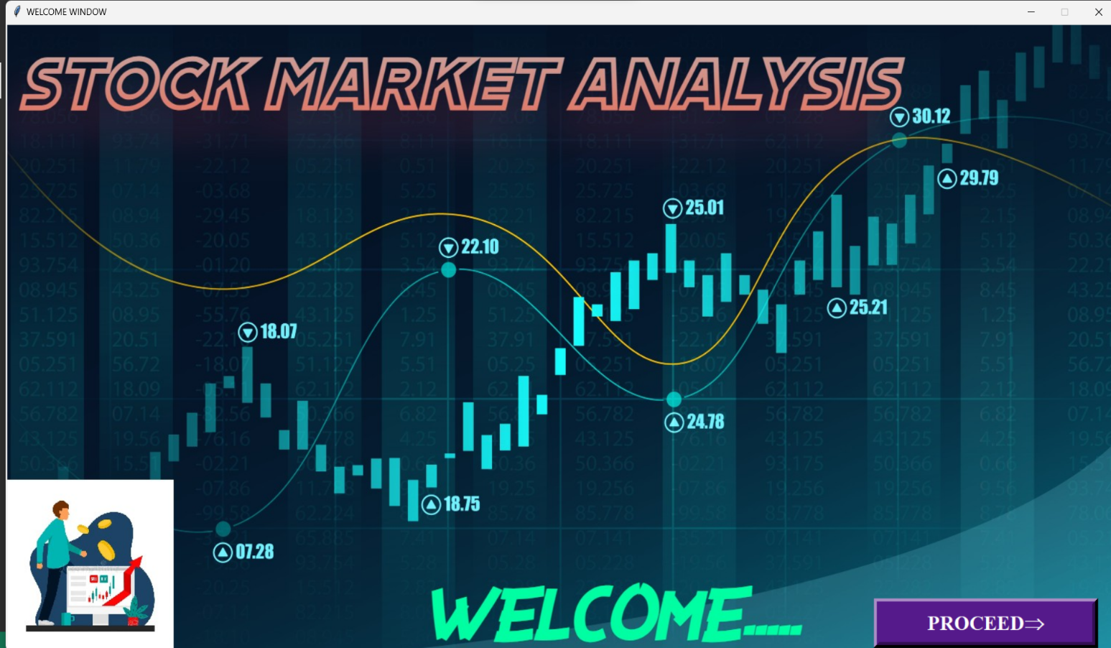

* **SIGNUP WINDOW**

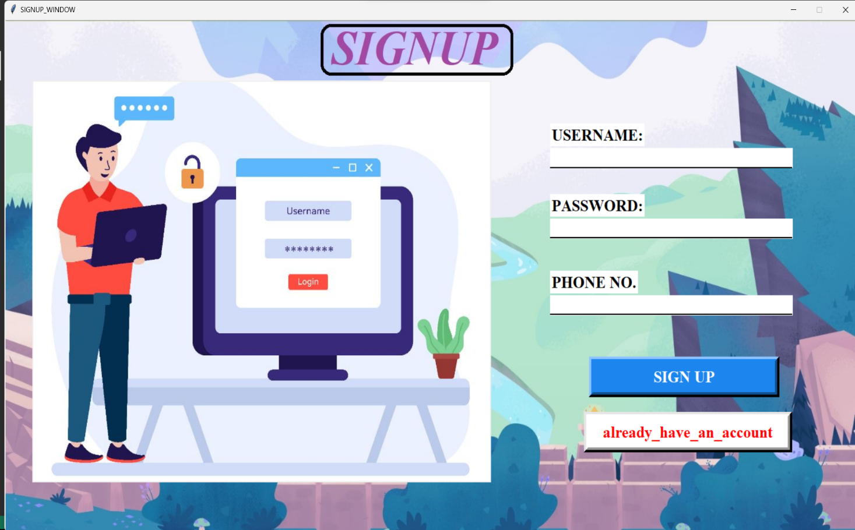

* **LOGIN WINDOW**

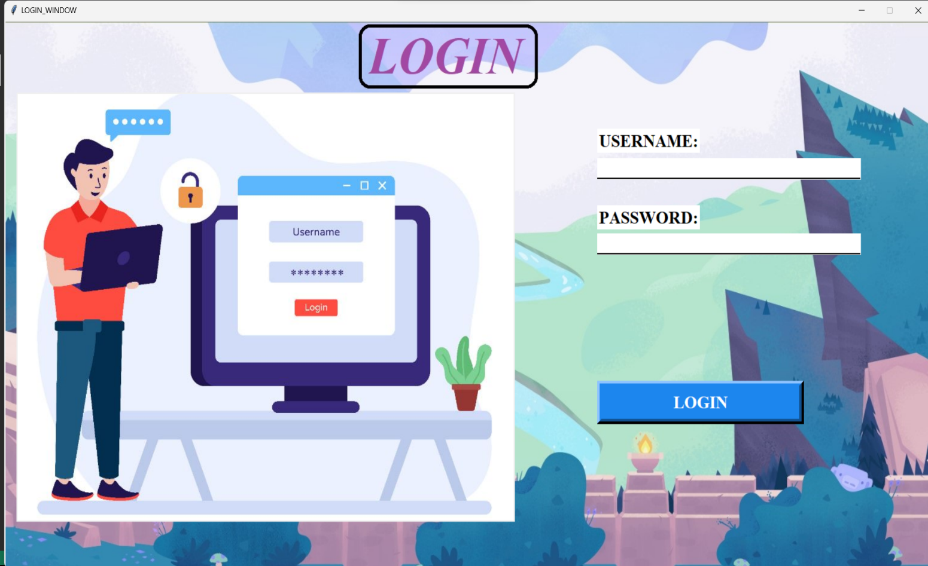

* **ACCESS WINDOW**

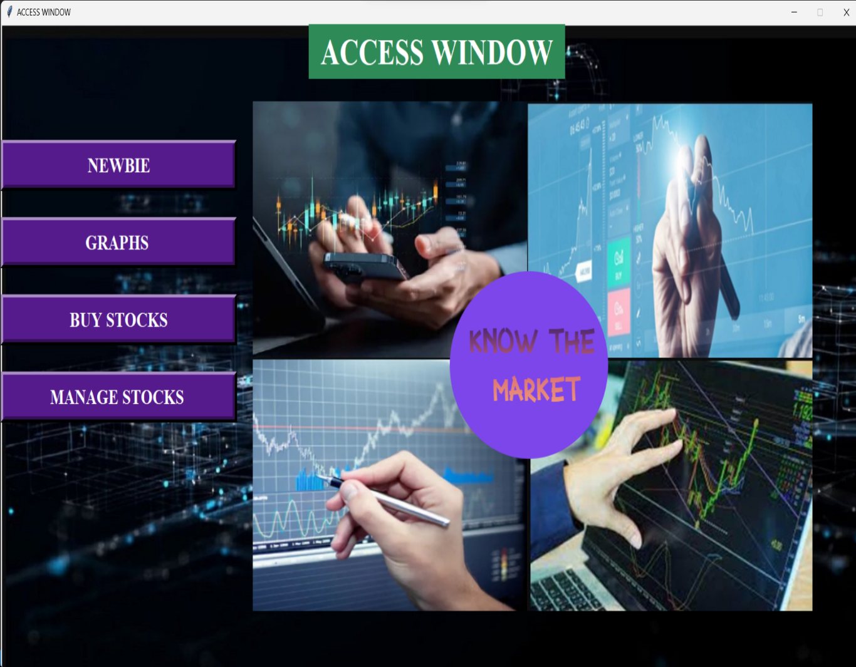

* **INTRO WINDOW**

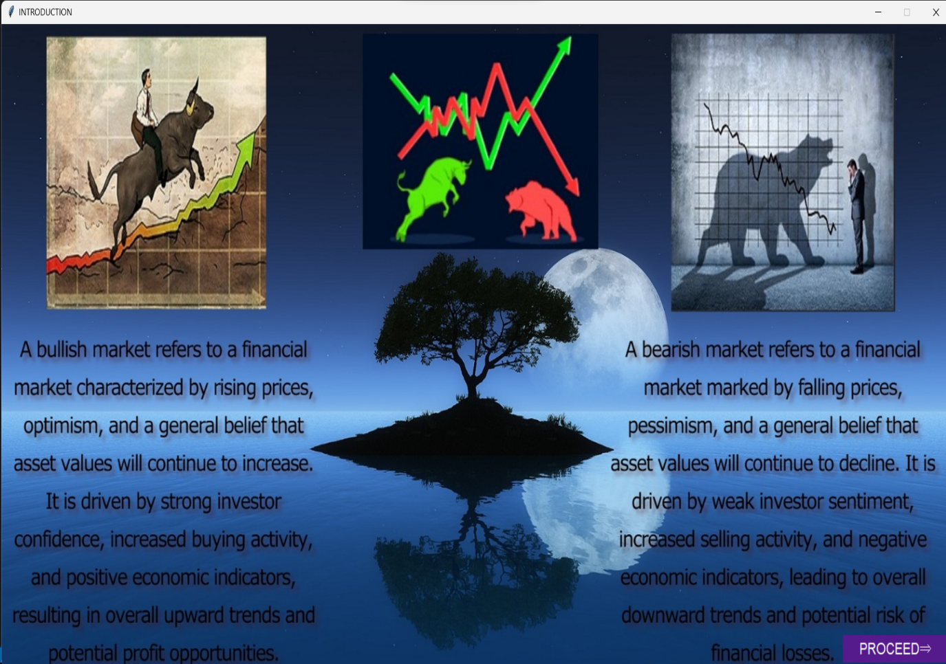

* **SGRAPH WINDOW**

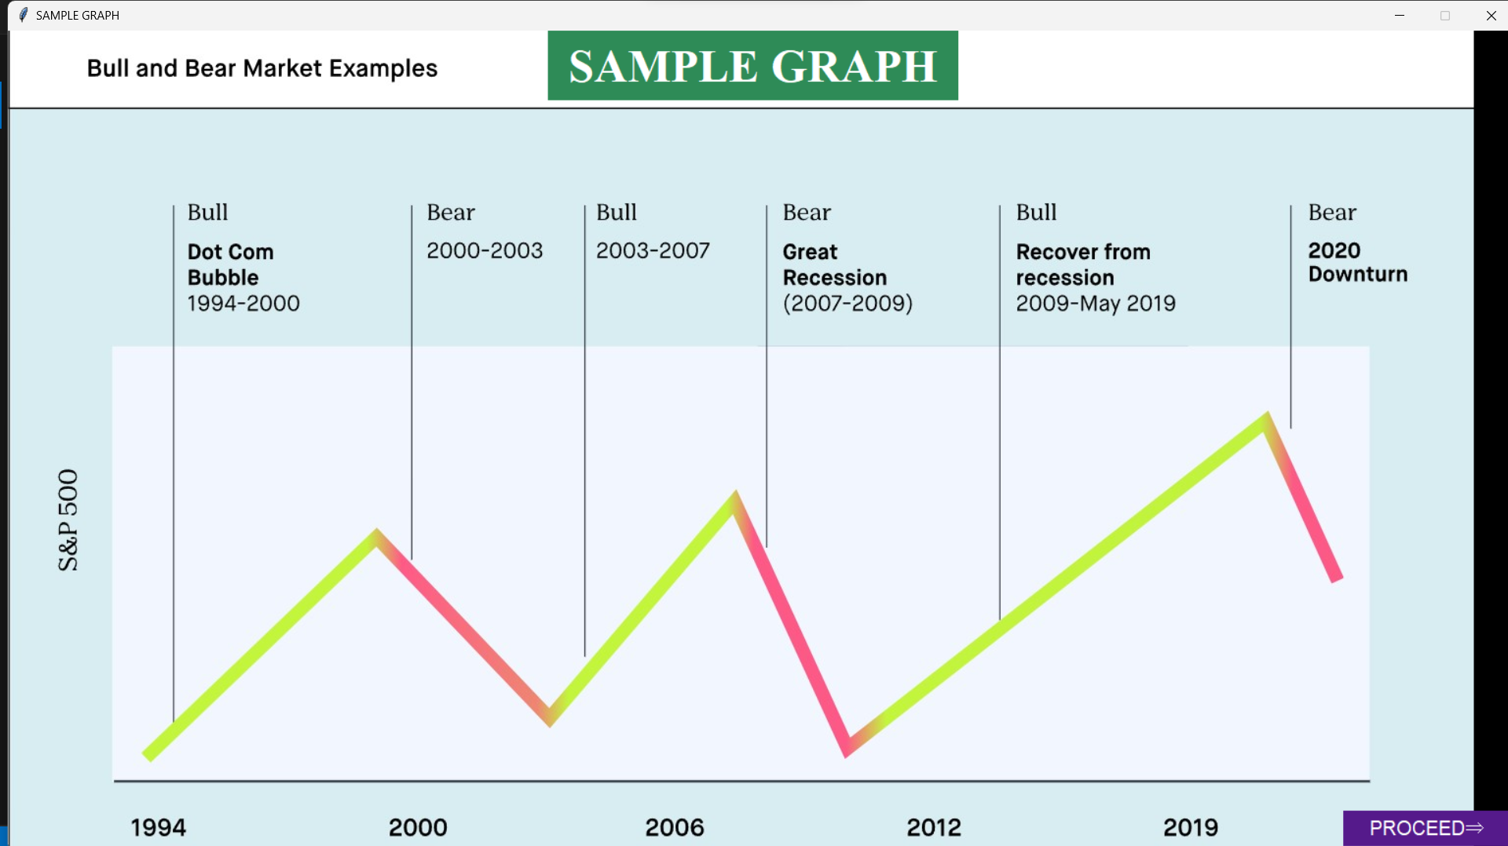

* **GRAPH WINDOW**

**(FOR GRAPH ANALYSIS)**

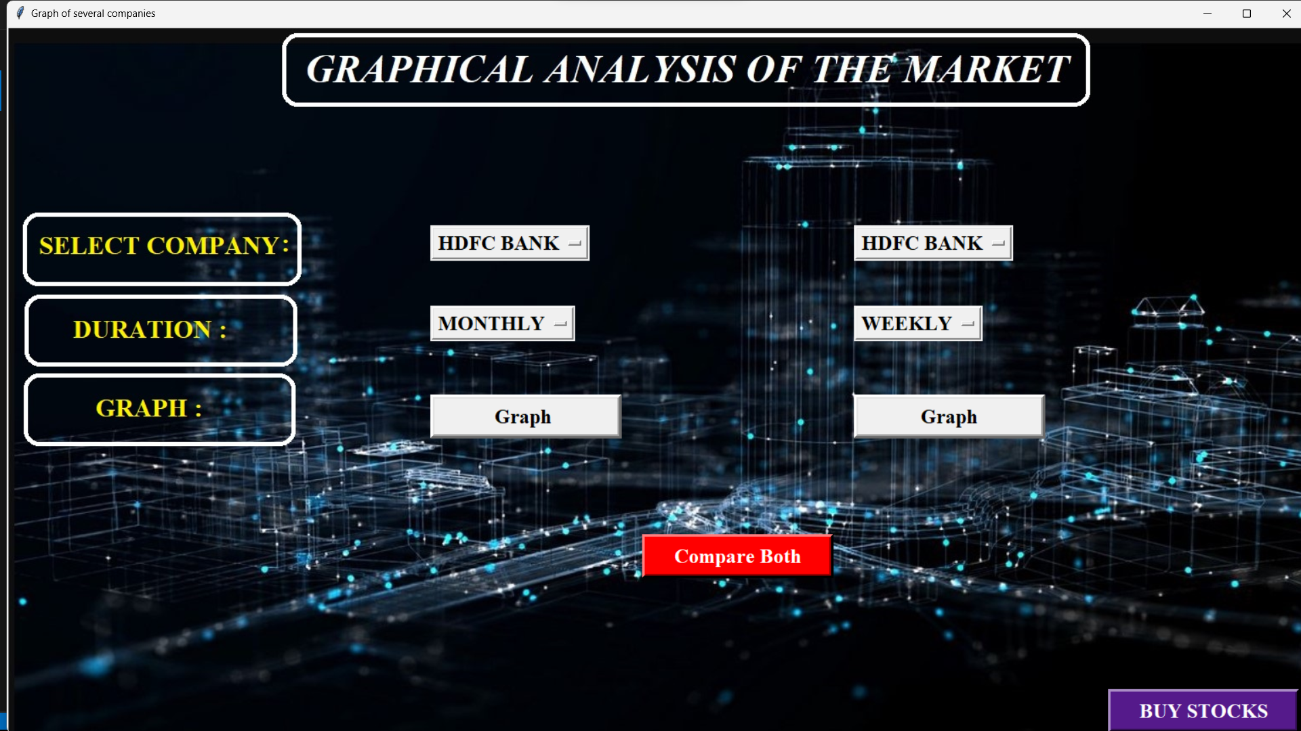

* **BUY WINDOW**

**(FOR ADDING STOCKS)**

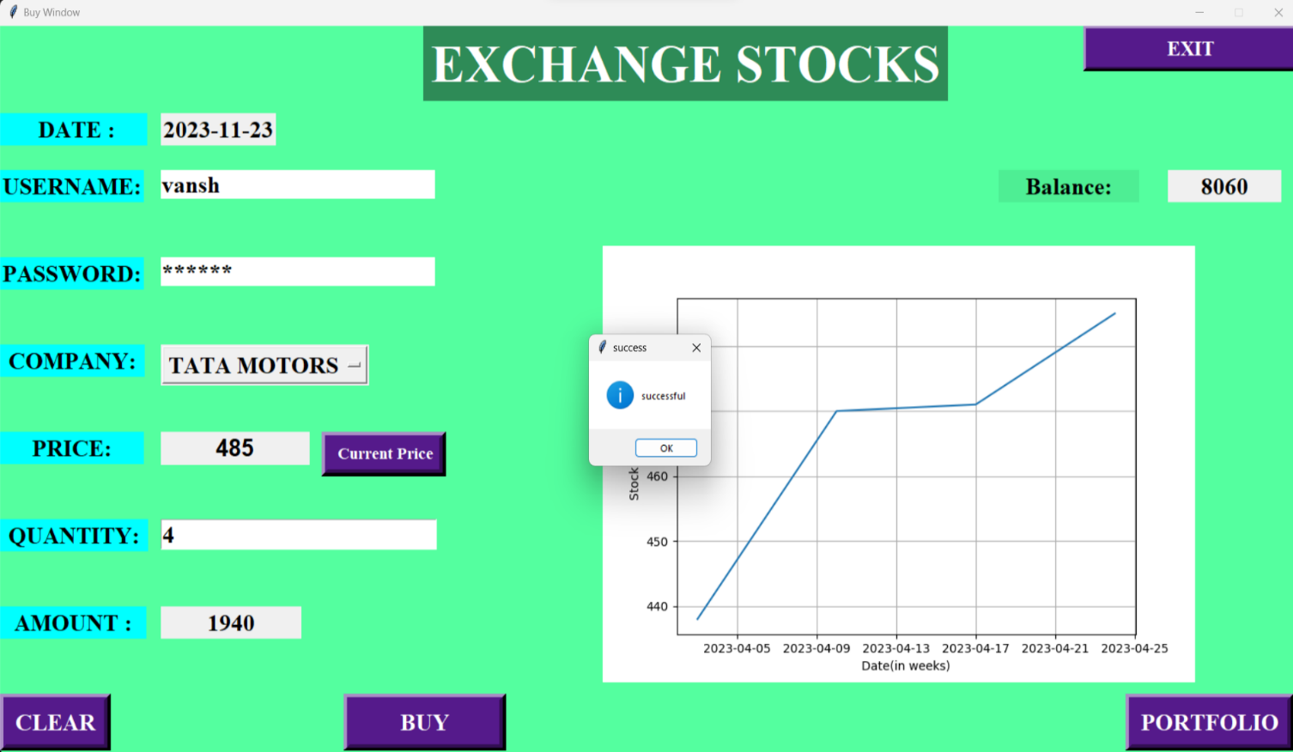

* **PORTFOLIO WINDOW**

**(FOR ACCESSING YOUR PREVIOUS ACTIVITY)**

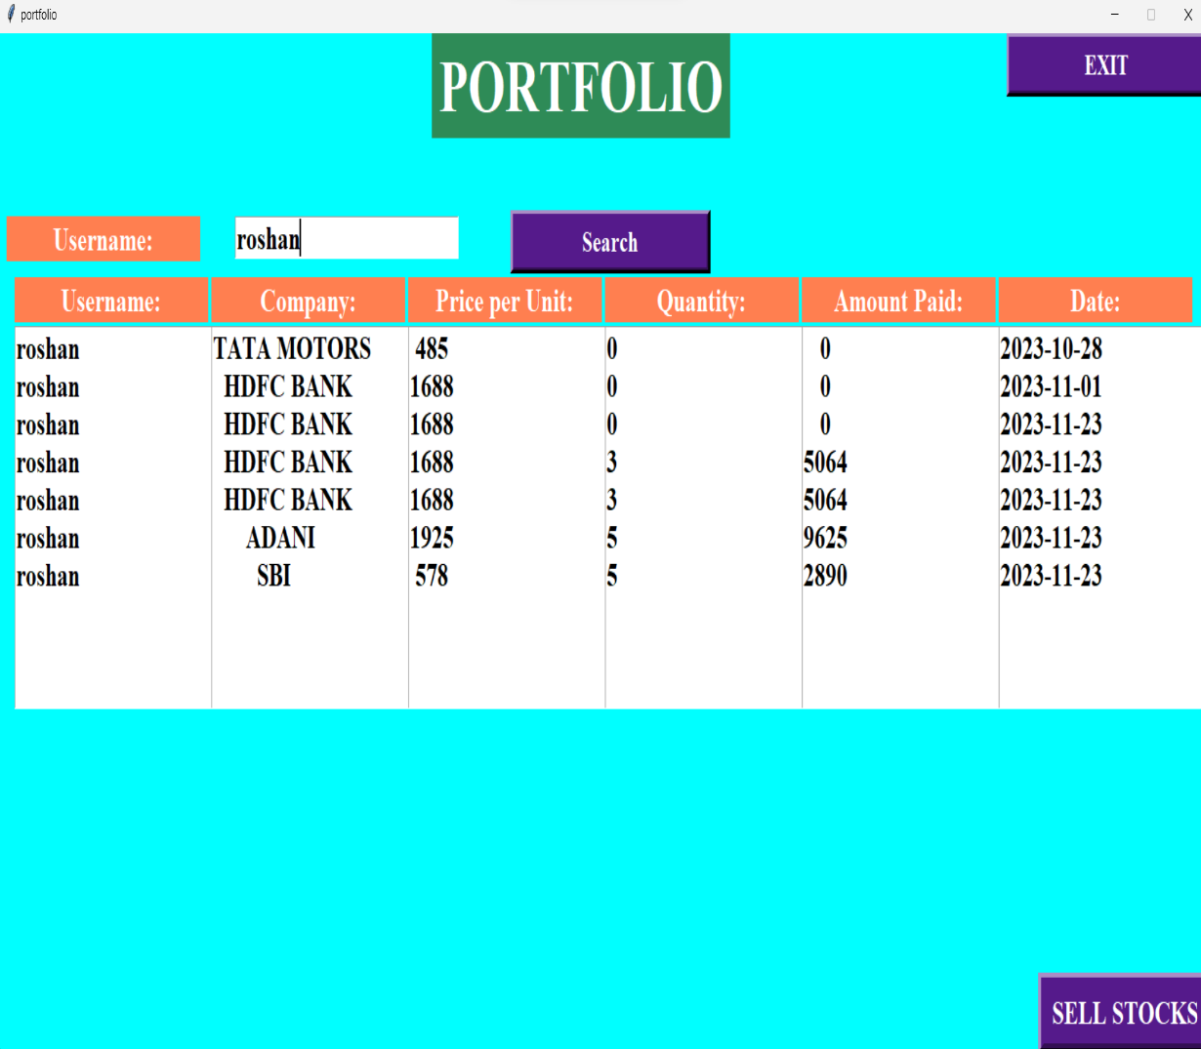

* **SELL WINDOW**

**(MANAGE YOUR DATA)**

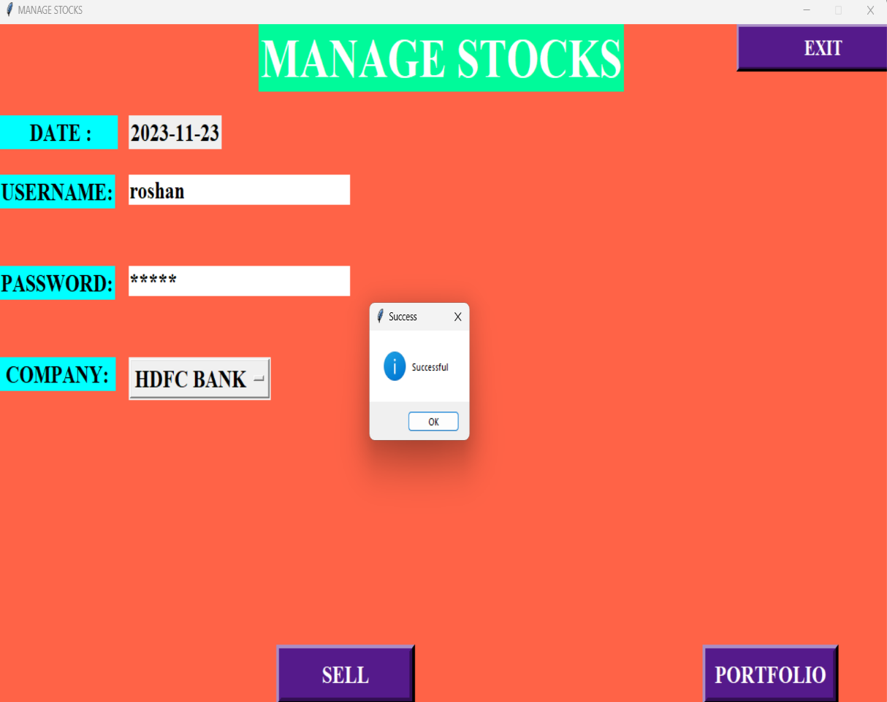

**REFERENCES / BIBLIOGRAPHY**

* **SUMITA ARORA CLASS 12 IP**
* [**https://stackoverflow.com/**](https://stackoverflow.com/)
* [**https://www.geeksforgeeks.org/**](https://www.geeksforgeeks.org/)
* [**https://www.plus2net.com/**](https://www.plus2net.com/)